Week 7: Lab (GP and MOLP Modeling)
Scenario/Summary:
In the realm of business, business manages and leaders are always looking for optimal solutions to help in the decision-making process. During Weeks 2 and 6, everyone explored Linear Programing (LP) models to create sensitivity analysis reports and to use output from the LP models to make decisions. Now we are going to go further with Linear Programing (LP) models exploring integers, goal programming, and multiple objective optimization. For the nature of these models, a manager or leader is able to learn there are several different variations and options with Linear Programing (LP) models that can output data analysis suited for a specific case and need to support the decision-making process.
- To go further into the theory of using Linear Programing (LP) models, use a minimum of three academic sources of research and prepare a minimum of three pages covering situations and examples of how Integer Linear Programming models, goal programing and multiple objective optimization can find optimal solutions, and how managers can use these different types of models to support their decision-making needs. Furthermore, also discuss if one model is better than the other or if these models need to be used based on the situation itself, and defend your answer with research support.

- In the conclusion of this paper, you will reference and apply understanding of Linear Programing (LP) models with an application of skills beginning with Step 3.

- The city of DeVry has been asked to determine the tax rate structure for the 2017 year. Based on current and proposed future needs to efficiently operate, the city needs to generate $6 million. Available taxable areas include properly, sales, prepared food, and utilities extracted from low, middle, and upper income groups. At present, the following is tax revenue generated per a 1.00% tax rate.

Revenue Per 1.00% Tax Rate (In 1000s)
Income Group | Sales Tax | Property Tax | Food Tax | Utility Tax
Low | $ 200 | $ 600 | $ 50 | $ 80
Middle | $ 250 | $ 800 | $ 100 | $ 100
Upper | $ 400 | $ 1,200 | $ 120 | $ 120

- Based on historical data of previous years, the tax rate for include properly, sales, prepared food, and utilities must be between 1.00% and 3.00%. Furthermore, and based on census data and population spread, the city has a goal of reaching $6 million receiving tax revenues of $1.5 million from low-income groups, $2.1 million from middle-income groups, and $2.4 million from upper income groups.

- With this data, the city of DeVry would like a solution that minimizes the maximum percentage deviation from these tax revenue goals for each of the income groups.

- To get started, use the illustration below as a guide to design your GP model.

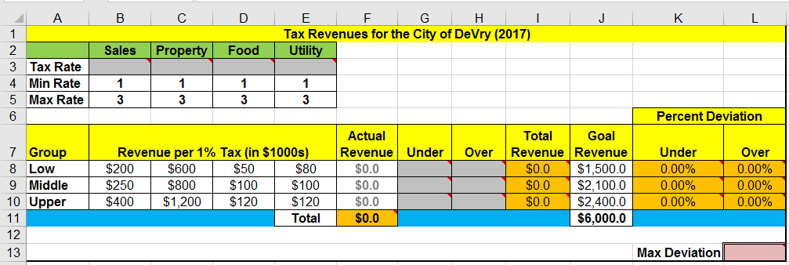
- Cells marked in the color grey are variable cells for this model.

- Cells marked in the color orange are constraints and will require formulas.

  - Cell F11 in the design of the model will total all revenue values with a formula like: =SUM(F8:F10). It should also be noted that cells F8 through F10 will require formulas also and the first formula for cell F8 will be something like: =SUMPRODUCT(B8:E8,$B$3:$E$3). Use similar formulas for cells F9 and F10, which are needed for the overall cell F11 constraint.
  - Cell I8 through I10 will include total revenues for each income group, and the first formula for cell I8 would be something like: =F8+G8-H8. Use similar formulas for I9 and I10.
  - Cell K8 through K10 will determine percent deviation (under) for each income group, and the first formula for cell K8 would be something like: =G8/J8. Use similar formulas of K9 and K10.
  - Cell L8 through L10 will determine percent deviation (over) for each income group and the first formula for cell L8 would be something like: =H8/J8. Use similar formulas of L9 and L10.

- Cell L13 in the color soft red is the objective cell.

- Now with the model ready and all formulas in place, use Solver to find a solution that minimizes the maximum percentage deviation from these tax revenue goals for each of the income groups.

- Activate the Solver tool and the “Set Objective” will be max deviation.

- The “By Changing Variable Cells” will be all cells from B3 through E3—the grey highlighted cells in the illustration. These are the cells with purpose for manipulation.

- There are five primary constraints, and the first constraint deals with tax rates. The left side of the constraint will use the tax rate less than or equal to the right side, which is the max rate.

- The second constraint deals with tax rates. The left side of the constraint will use the tax rate greater than or equal to the right side, which is the min rate.

- The third constraint deals with revenue. The left side of the constraint will use actual revenue = to the goal revenue on the right side.

- The fourth constraint deals with revenue. The left side of the contract will use total revenue = to the goal revenue on the right side.

- The fifth constraint deals with percent deviations. The left side of the contract will use percent deviations (under and over) less than or equal to the objective max deviation on the right side.

- Check if needed “Make Unconstrained Variables Non-Negative,” and for the solving method, use Simplex LP and click “Solve.”

- Include all available reports such as answer, sensitivity, and limits.

- Now with a few more constraints to consider with this model, use the illustration below as a guide for the input of these constraints.

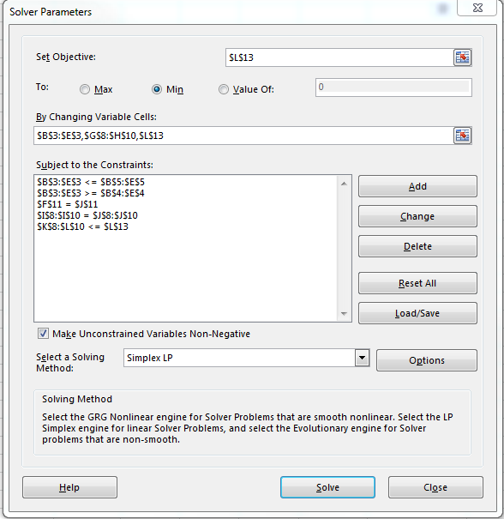

- What is the max deviation, or optimal solution, in this case? Based on this value and use of the answer, sensitivity, and limit reports, is this a feasible solution? Based on your best judgment, would you proceed with the proposed tax rates? Why, or why not?

- Going further with this model looking at long-term objectives, the city of DeVry is planning to receive $7 million and $15 million in tax revenues for the 2018 and 2019 respective future tax years in plans to build a state of the art high school that is technology driven.

- For the 2018 tax year objective of $7 million, use the same model and adjust the goal revenue values assuming 25% (lower income), 35% (middle income), and 40% (upper income). This is the same spread of the goal revenues of the first model run with a goal of $6 million.

- For the 2019 tax year objective of $15 million, use the same model and adjust the goal revenue values assuming 25% (lower income), 35% (middle income), and 40% (upper income). This is the same spread of the goal revenues of the first model run with a goal of $6 million.

- Based on the 2018 and 2019 model runs, what is the max deviation, or optimal solution, in these cases? Based on the outcomes, was Solver able to find a solution in both cases? If a solution was found, is the solution feasible, and would you proceed with the proposed tax plan? If there is not a solution, what suggestions would you possibly have with the assumption that the tax revenue for the 2018 and 2019 years is needed?

- Integrate your reflections and decisions into the conclusions of the main paper showing correlation based on what you learned from both your research and application of LP models to find optimal solutions for the 2017, 2018, and 2019 tax plans.

- Save both your assignment files in Microsoft Word and Excel, and name the files Week_7_Lab_StudentName.docx and Week_7_Lab_StudentName.xlsx.

- Submit both the Microsoft Word and Microsoft Excel assignment files to the Week 7 Lab Dropbox.

Week 7: Lab (Grading Rubric)
Category | Description | Points Earned
Topic Selection | The topic clearly identifies and goes further into the realm of Linear Programming (LP) models covering integer, goal programming, and multiple objective optimization. | 5/5
Bibliography | The bibliography includes at least three references. References are authoritative and do not include anonymous authors. Web pages, if used, are clearly written by experts in the field (expert qualifications are given in the summaries). At least three references are peer-reviewed, scholarly papers. The bibliography is in APA format and is free of typographical, grammar, spelling, and formatting errors. | 5/5
Paper: Formatting | The paper is in 12-point Times New Roman font, double-spaced, and includes a cover page, table of contents, introduction, body of the report, summary or conclusion, and references. The Final Paper conforms to APA format. | 5/5
Paper: Organization and Cohesiveness | The paper includes an introduction that generates interest in the topic and previews the main points to be covered, a body that develops each main point, and a conclusion that summarizes the main points covered. There is a logical flow of ideas throughout the paper. There is a clear thesis statement for the paper and a clear topic statement for each major section. Appropriate transitions are used between topics and subtopics. | 5/5
Paper: Editing | The paper uses a professional writing style and is free of typographical, spelling, and grammar errors. | 5/5
Paper: Content | The paper is of the required length and fully addresses topics provided. Topic areas should include theory of how situations and examples of Linear Programming (LP) models covering integer, goal programming, and multiple objective optimization. The paper is at least 80% in the student’s own words (i.e., no more than 20% direct quotations from a source). | 35/35
Excel: Technology | Microsoft Excel is used properly to create a Linear Programming (LP) model using proper formulas and functions along with proper use of model constraints. | 30/30
Total | A quality paper will meet or exceed all of the above requirements. | 90/90
Comments

