Objective:

The purposes of this lab are to learn the use of a Vernier caliper, make some basic length measurements and to use these measurements to calculate volumes and densities.

Parts and Equipment Required:
- Vernier caliper
- 5 zinc plated steel washers
- 1 coin (U. S. quarter or equivalent)

Introduction:
Exact numbers are those that result from counting (such as the number of cars in a parking lot or the number of apples in a bushel) or by definition (1 hour = 60 minutes, 1 inch = 2.54 cm). ANY number that is the result of a measurement is by nature approximate. It is very important to express the result of any measurement to the correct number of significant digits. Too many digits written out implies that the number is more precise than you measured. Too few digits implies that you haven’t worked hard enough. In physics, words that may seem to be synonyms are not. For example, precision and accuracy may be used almost interchangeably in everyday language but as technical terms these words have very different meanings. The accuracy of an approximate number is a measure of how close the number is to its true value. The precision of an approximate number is the value or position of the least significant digit. The relative precision of a measured number is the least significant digit divided by the value expressed as either a fraction or a percentage. For example, the measurement 2.14 V has a precision of 10 mV and a relative precision of 0.01/2.14 = 0.0047 or 0.47 %. Review the rules of significant digits in your text.
Volume is the total amount of space (in cubic units) that any object occupies. Mass density is the ratio of the mass of an object to its volume. For most solids and liquids the mass density is a constant property of the material. A table of the standard masses of U.S. and Canadian coins is below. Keep this table handy; you will need it for later experiments.

coin | Cent (penny) | Nickel | Dime | Quarter | Half-dollar | Dollar
U. S. (g) | 2.500 | 5.000 | 2.268 | 5.670 | 11.340 | 8.1
Canadian (g) | 2.35 | 3.95 | 1.75 | 4.4 | 6.9 | 7

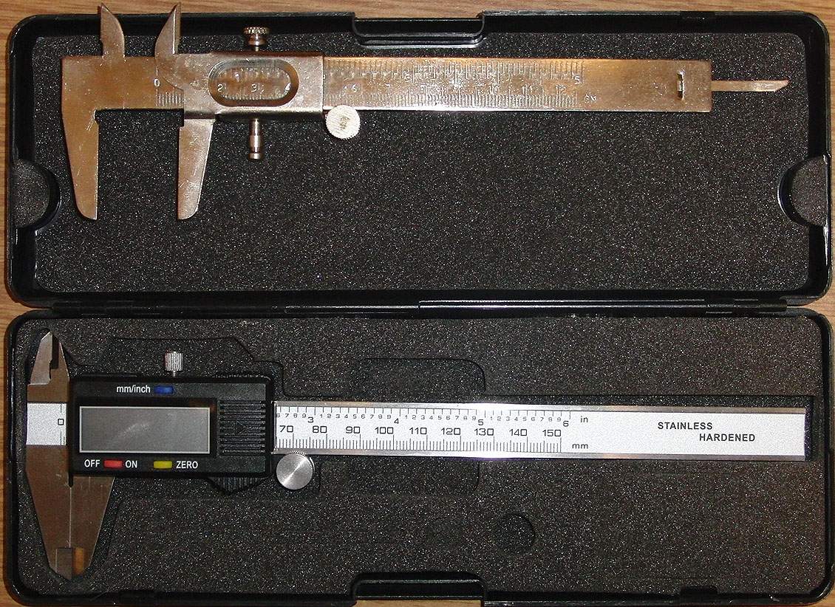
A Vernier caliper (see Figure 1) is a device used by machinists, technicians, engineers and scientists to measure the dimensions of object ranging in size from a fraction of a centimeter to 15 cm to a precision of a fraction of a millimeter. There are two sets of scales on a Vernier caliper. One set is in inches and the other is metric. The fixed metric scale is located on the lower part of the beam and is marked in centimeters and millimeters. The sliding metric scale is called the Vernier and is nine millimeters marked into ten divisions. Figure 2 shows a diagram of a Vernier that reads to tenths of a millimeter which means that the precision of the caliper is 0.1 mm or 0.01 cm. To read a Vernier caliper in metric units, you:
Figure 1 Vernier and Digital Calipers
- Find the number of whole millimeters by reading the number of the mm graduation on the fixed scale that is just to the left of the zero graduation on the Vernier scale.
- If the zero graduation is not directly in line with a graduation on the fixed scale, find the graduation that is most nearly in line with any graduation on the fixed scale.
Figure 2 Diagram of a scale with Vernier
- Count the number of graduations on the Vernier scale to find the number of tenths of millimeters in the measurement.
- Add the numbers from step 1 and step 3 to find the total distance between the jaws of the caliper.
Figure 3 Diagram of a Vernier showing a measurement of 0.54 cm
For example, Figure 3 shows a measurement of 0.54 cm or 5.4 mm and Figure 4 shows 2.02 cm or 20.2 mm.
The purpose of this assignment is for you to use your caliper to measure the dimensions of some common objects and to use your measurements for some basic calculations.

Procedure:

- Measure the outer diameter of each washer with the Vernier caliper as shown in the Figure 5. Record your results in the table on the data sheet. Find the average. Be sure to include the proper units and number of significant digits.
Figure 4 Diagram of a vernier showing a measurement of 2.02 cm
- Measure the inner diameter of each washer with the Vernier caliper as shown in the Figure 6. Record your results in the table on the data sheet. Find the average. Be sure to include the proper units and number of significant digits.
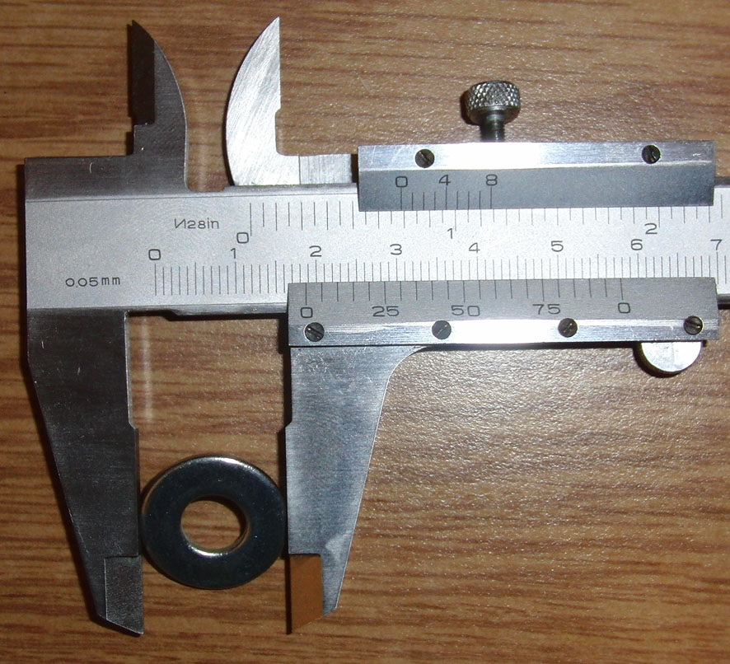
- Measure the thickness of each washer with the Vernier caliper. Record your results in the table on the data sheet. Find the average. Be sure to include the proper units and number of significant digits.
Figure 5 Measuring the diameter
- Find and record the average volume (V) and the mass density (ρ) of the washers. Be sure that the units are in centimeters and grams. The formulae are: $V=π\left({r_{outer}}^{2}-{r_{inner}}^{2}\right)t$ and $ρ=\frac{m}{V}$ where r _{outer} and r _{inner} are the outer and inner radii of the washer, t is the thickness and m is the mass. The average mass of these washers is 2.7±0.2 grams.
- Look up the mass density of iron in g/cm³ and compare the value you found with your measured value by calculating a percent difference. Is this percent difference reasonable? Explain.
- Measure the diameter of the quarter with the Vernier caliper five times at different points on the coin, record your results in the table on the data sheet. Be sure to include the proper units and number of significant digits.
- Measure the thickness of the quarter with the Vernier caliper five times at different points on the coin, record your results in the table on the data sheet. Be sure to include the proper units.
- Find and record the volume and the mass density of the quarter. The formulae are: $V=πr^{2}t$and$ρ=\frac{m}{V}$.
- Look up the mass density of the coin in g/cm³ and compare the value you found with your measured value by calculating a percent difference. Is this percent difference reasonable? Explain.
- Divide your height (in centimeters) with the thickness of the coin to find how many quarters would be required to make a stack as tall as your height. What is the mass of the stack of coins?
- Record all data on the data sheet, answer all questions, and turn in your data sheet.
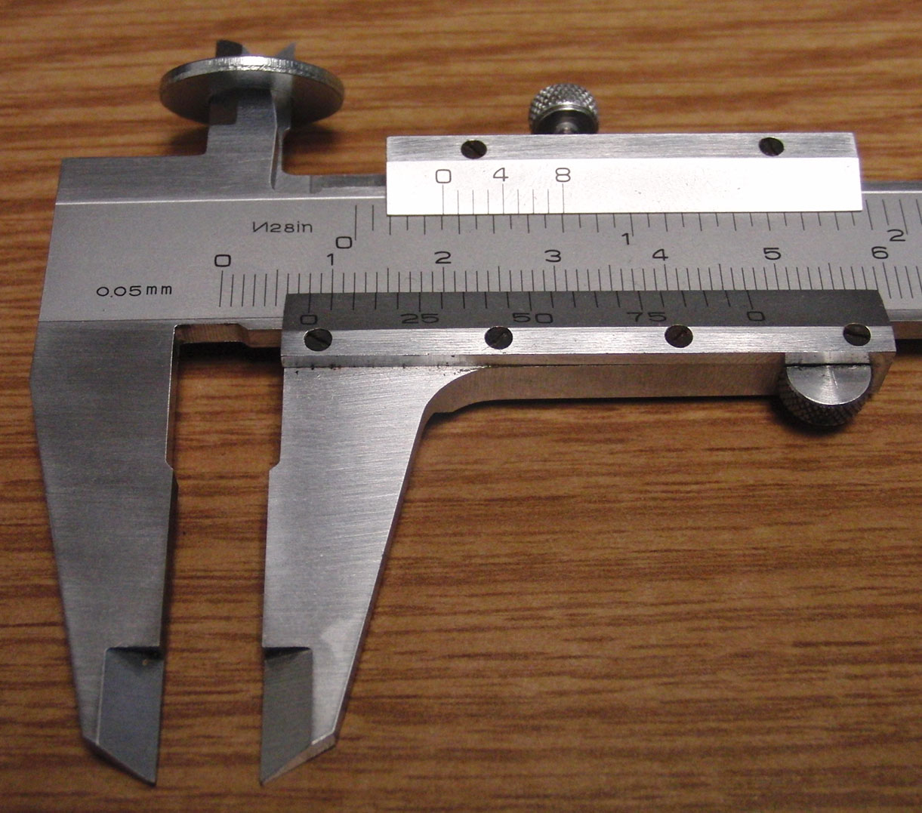
Figure 6 Measuring the inner diameter

