

PHYS310 iLab Experiment 1

Equipment Checkout and PASCO Capstone Tutorial

**Part 1: Equipment Checkout (required, but not graded)**

Physics is an experimental science. Physical concepts are only held to be conditionally true as long as they are supported by experiment or observation. The beginning of modern physics can be traced back to Galileo. Galileo systematically used experiments to guide and test his theoretical ideas. He proved experimentally that Aristotle’s hypothesis on free fall (heavy objects fall faster than the light ones) is wrong. He showed that two objects of different masses that are simultaneously dropped from the top of Pisa’s tower hit the ground at the same time. He then discovered the law of free fall in a gravitational field by

studying the motion of objects rolling or sliding on the inclined plane and used these results to formulate the first principle of mechanics (later included by Newton in his *Principia*

*Mathematica*).

The laboratory is a workshop in which students can gain firsthand knowledge of the physical principles and experimental methods used in physics. For the student, some of the objectives of a laboratory exercise are to

• train in scientific methods of observation;

• acquire experience handling scientific and other electronics equipment;

• collect scientific data; and

• compute reliable results and draw valid conclusions from data.

For these reasons, all physics students should have the opportunity to participate in some form of laboratory experiment or exercise.

At the start of the course, you should order the required equipment kit as soon as possible. During Week 1, you should receive your kit and check the contents against this packing list. **See PHYS310 Lab Equipment and Supplies**. Report any discrepancies to your instructor. Please remember to read through the laboratory exercises well in advance of the due date to make sure that you have everything that you need.

**Required Equipment:**

**PS-3200 PASCO AirLink:** This component is used to interface PASCO PASPORT sensors with your computer to allow real-time data acquisition.

The AirLink is shown in Figure 1.

**PS-2103A PASCO Motion Sensor:** This component is used with the AirLink and PASCO Capstone to measure distance, velocity, and acceleration.

The motion sensor is shown in Figure 2.

**PS-2189 PASCO High Resolution Force Sensor:** This component is used with the AirLink and PASCO Capstone to measure force.

This sensor is shown in Figure 3.

**Figure 1: PASCO AirLink**

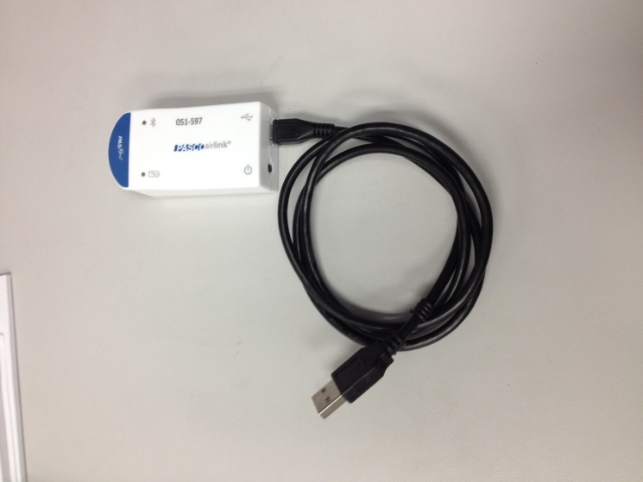

**Figure 2: PASCO Motion**

**Sensor**

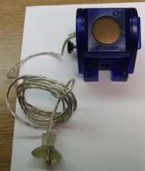

**Figure 3: PASCO High**

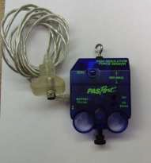**Resolution Force Sensor**

**DeVry PHYS310 Laboratory Supplies Kit, eScience Labs**

This kit **(KIT2533)** contains the balance of the equipment and supplies needed to complete the laboratory portion of PHYS310.

The contents of the kit are listed here.

|  |  |
| --- | --- |
| 1 | Caliper |
| 1 | Fan Cart |
| 2 | AA Batteries |
| 1 | Mass Set |
| 1 | Spool Thread |
| 1 | Fishing Line, 10 ft. |
| 1 | Polypropylene Graduated Cylinder (250 ml) |
| 1 | Table Clamp Pulley |
| 1 | S-clamp |
| 1 | #8 Rubber Stopper With Hole |
| 1 | #6 Rubber Stopper With Hole |
| 1 | Safety Glasses |
| 1 | PVC or Aluminum Tube 0.5 in. o.d. 12 in. Long |
| 2 | Plastic Beaker (250 ml ) |
| 2 | Styrofoam Cup |
| 2 | Plastic Cup |
| 2 | Paper Cup |
| 1 | Wooden Ruler, 12 inch With cm Marking and Central Groove |
| 5 | Marbles |
| 1 | Hardware Bag (including 6 hex nuts, 2 bolts, 15 washers, 3 fishing sinkers, 1 large hex  nut) |
| 1 | Cardboard Ramp |

**Part 2: PASCO Capstone Installation (required but not graded)**

PASCO Capstone is the software that will allow you to acquire, analyze, and present data from the experiments in this course. Download and install PASCO Capstone from the Student Software Store by following the instructions provided in the last section of the lab

**Part 3: PASCO Capstone Tutorial (graded) Objective**

The objective of this exercise is to become familiar with some of the data analysis tools of the

PASCO Capstone software.

**Parts and Equipment Required**

• Computer with PASCO Capstone installed

**Introduction**

Computer acquisition and analysis of experimental data offers many advantages. Data are measured automatically and with greater precision than data measured by hand. The data are immediately stored in an electronic format and are available to be quickly graphed. There are also a wide variety of computerized data analysis tools available. PASCO Capstone is the software that we will use in this course to acquire and analyze experimental data. The purpose of this tutorial is for you to become familiar with PASCO Capstone and some of its tools.

**Procedure**

• Start PASCO Capstone by clicking on the program name in the Start menu.

• When PASCO Capstone opens, click on the Calculator button on the left side of the screen to expand the calculator tool panel as shown in Figure 4.

**Figure 4: Expanding the Calculator Tool Panel**

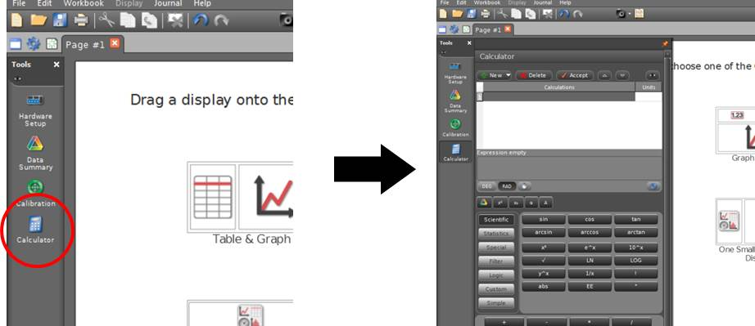

• Type the equation *y* = exp(-*x*) into the first calculator expression line (Figure 5) and click Accept.

• The calculator will identify *x* as a variable and show its definition “*x* =” on the next expression line. Right click on this line and select Insert Model Range; set the range from 0 to 10 in 100 steps as shown in Figure 5.

**Figure 5: Creating a Model Range**

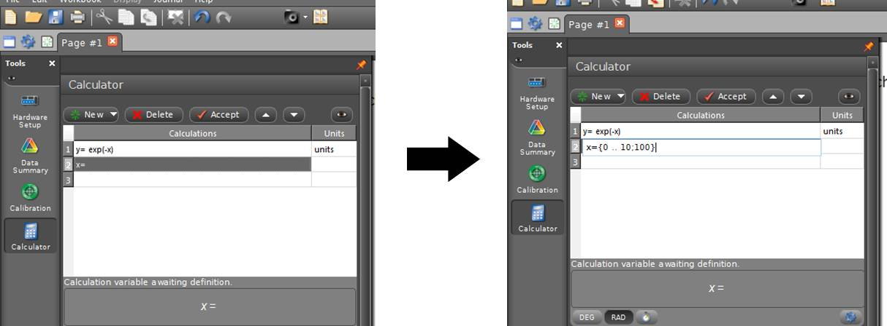

• Click the Calculator button again to collapse the calculator tool panel, and then double-click the graph button on the right side of the screen to create a blank graph display.

• Click the Select Measurement button along the graph’s *y*-axis and choose the “y” function from the list under Equations/Constants. The curve representing the   
*y* = exp(-*x*) function will appear on the graph.

• Copy the graph from PASCO Capstone by making the graph the active window and selecting Copy from the Edit Menu.

• Paste the graph into the datasheet (*PHYS310\_W1\_lab1\_datasheet.docx*) at the appropriate location by selecting Paste Special from the paste menu and then selecting Device Independent Bitmap*.* The graph should appear on the datasheet and can then be formatted and resized if you choose.

• Activate the graph’s Coordinates Tool shown in Figure 6, and drag the tool onto the graph to find the coordinates of the curve at the point *x* = 0.5

• Activate the graph’s Slope Tool shown in Figure 6, and drag the tool onto the graph to find the slope of the curve at the point *x* = 2.0.

• Record the results to answer question 2 on your datasheet.

**Figure 6: Activating the Coordinates Tool and Slope Tool**

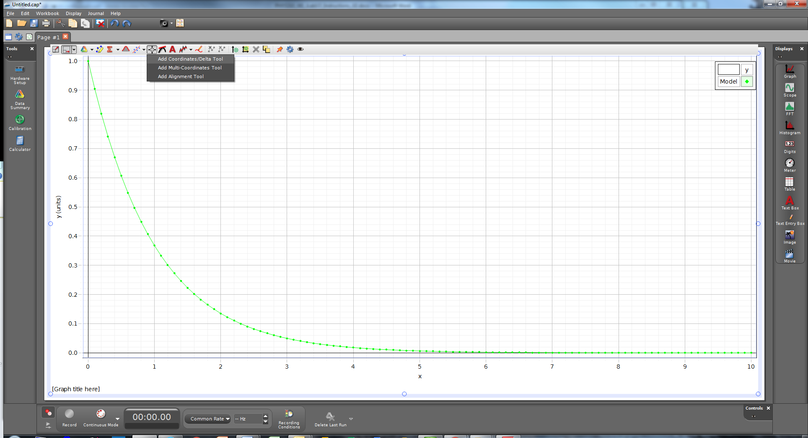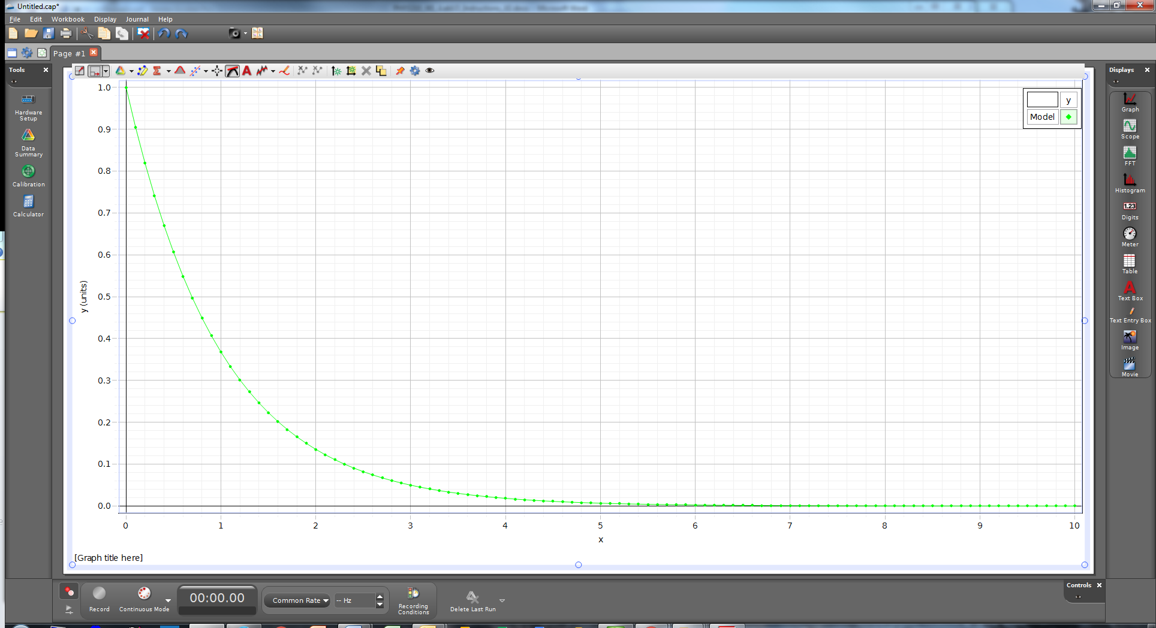

• Click the Add Page button 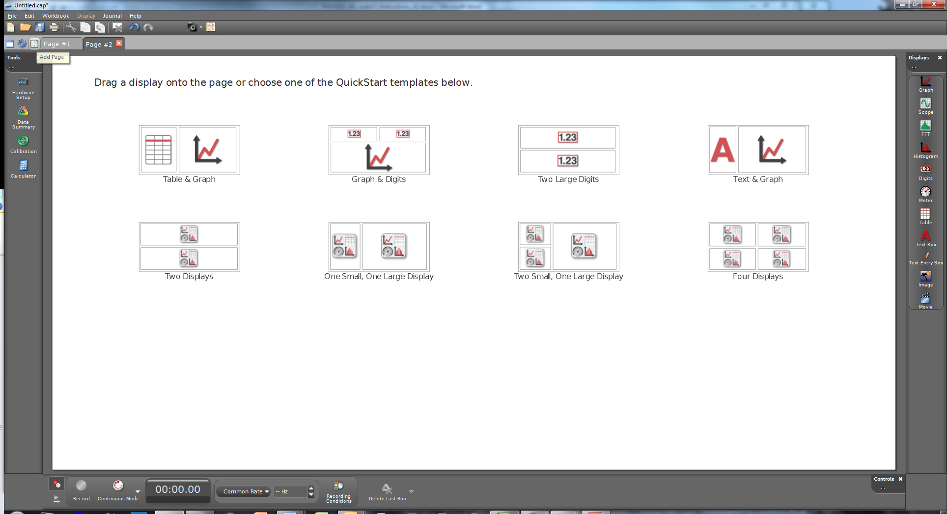 above the Tools Panel, and then select the Table & Graph template in the new blank page as shown in Figure 7.

**Figure 7: New Page with Table and Graph**

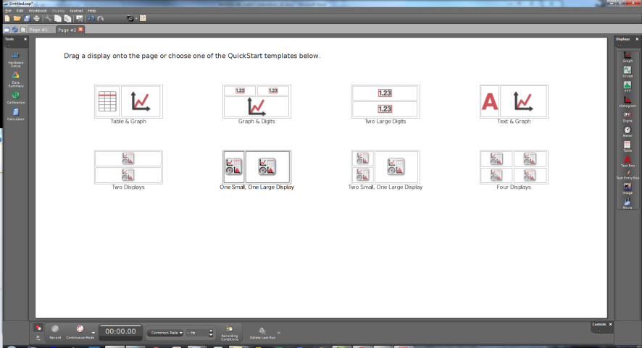

• Type the values from Table 1 below into the blank columns of the table.

• When you begin typing into the columns, the table will automatically name the columns User Data 1 and User Data 2. Click on each column name and rename them to X and Y (both capital letters), like the table below.

• In the graph, click the Select Measurement buttons along both axes and choose Y for the *y*-axis and X for the *x*-axis.

• Click the curve fit drop-down button in the graph and select Linear from the list to find the best straight line fit to the data.

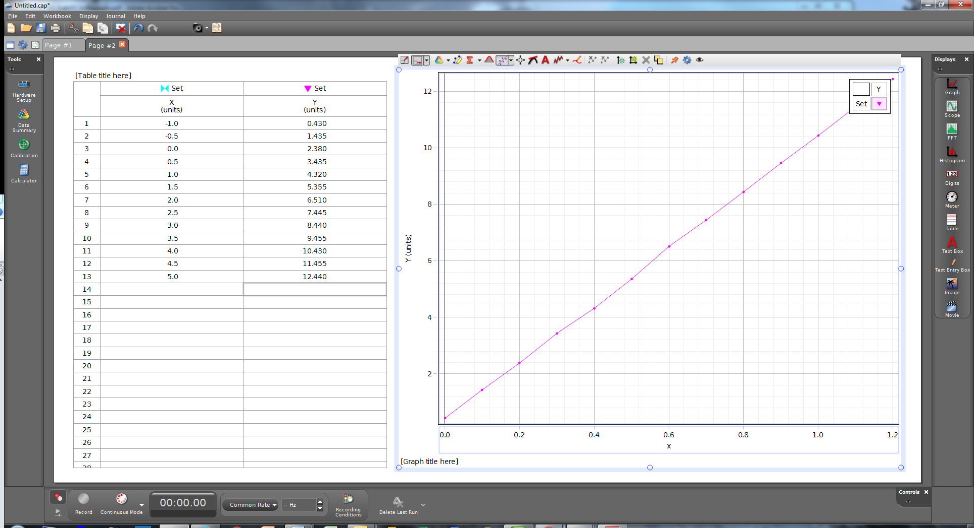

• Record the values of the slope and the *y*-intercept on your datasheet.

• Save your datasheet.

• Turn the datasheet in to your instructor.

**Table 1: Sample Data for Graph**

|  |  |
| --- | --- |
| *X* | *Y* |
| -1 | 0.43 |
| -0.5 | 1.435 |
| 0 | 2.38 |
| 0.5 | 3.435 |
| 1 | 4.32 |
| 1.5 | 5.355 |
| 2 | 6.51 |
| 2.5 | 7.445 |
| 3 | 8.44 |
| 3.5 | 9.455 |
| 4 | 10.43 |
| 4.5 | 11.455 |
| 5 | 12.44 |

**Installing Capstone**

**Pasco Capstone volume license key:**  18jkm-5u0t7-afol1-j58ob-20qr6-c8933

To access PASCO Capstone, under Course Home, click on Course Resources and enter the Student Software Store

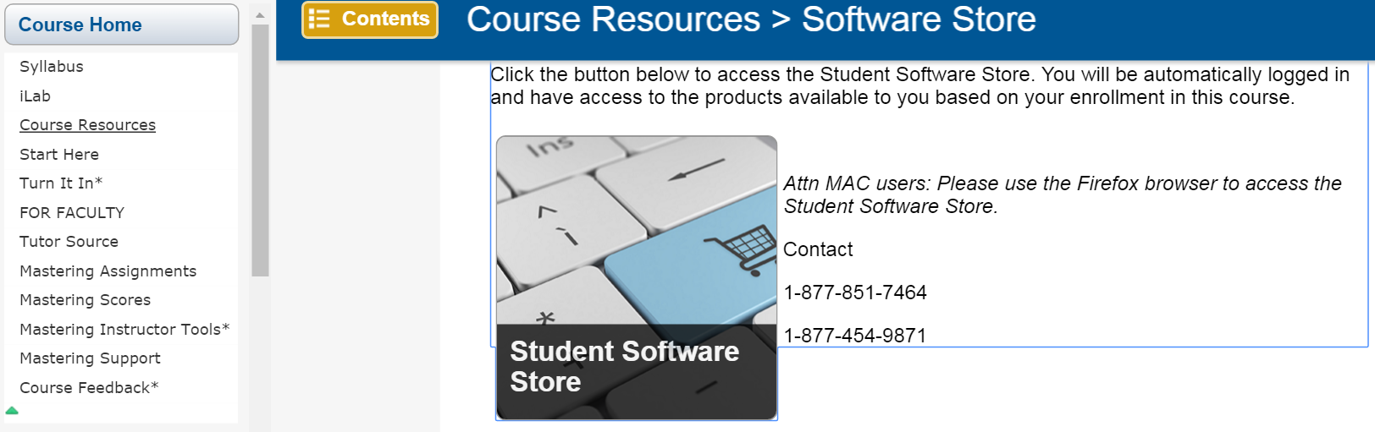

Click the Student Software Store button and a new window will pop up. Scroll down to Go To the Student Software Store and click



In the pop-up window, click on Course Related Software



Click on Pasco Capstone

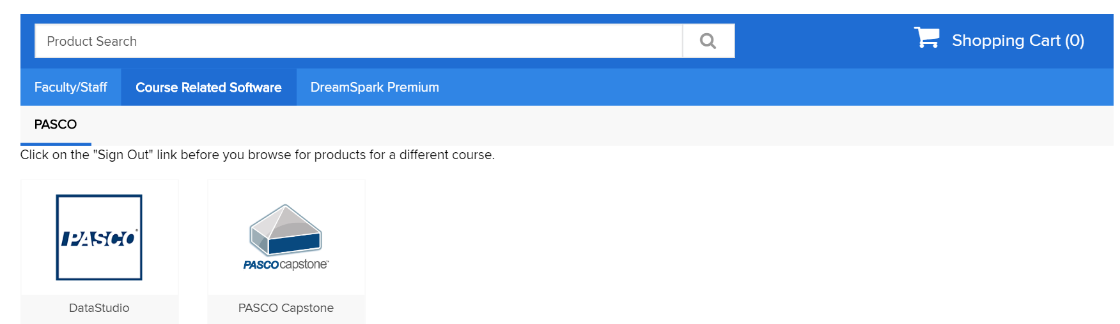

Add to Cart

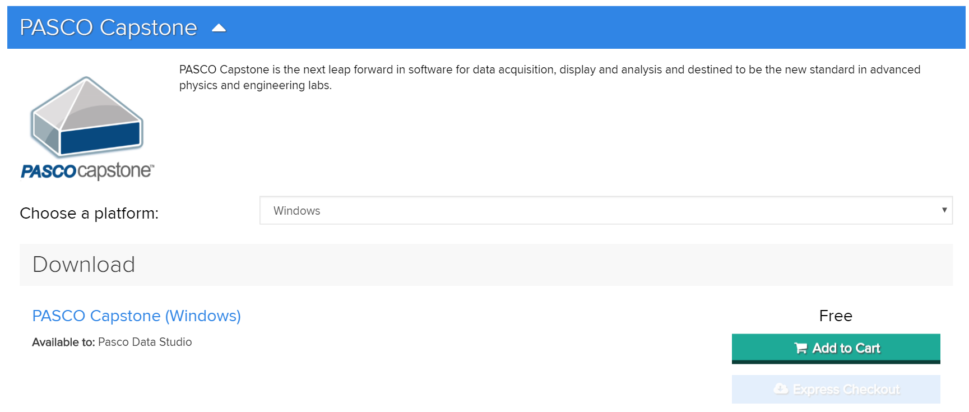

Checkout through the shopping cart and download your software

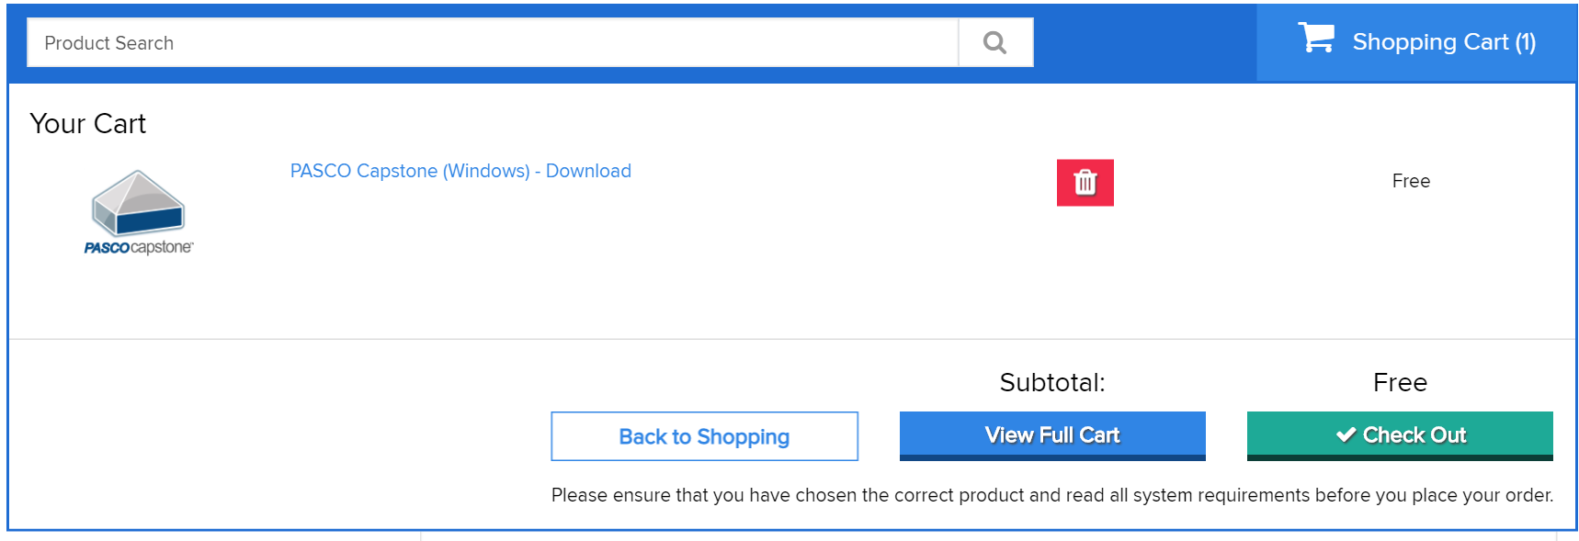

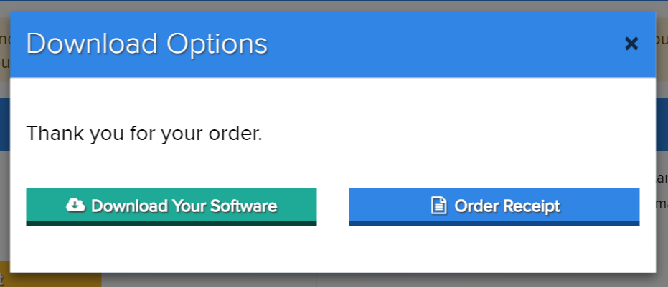

Download the SDX manager then download then download the .SDX file

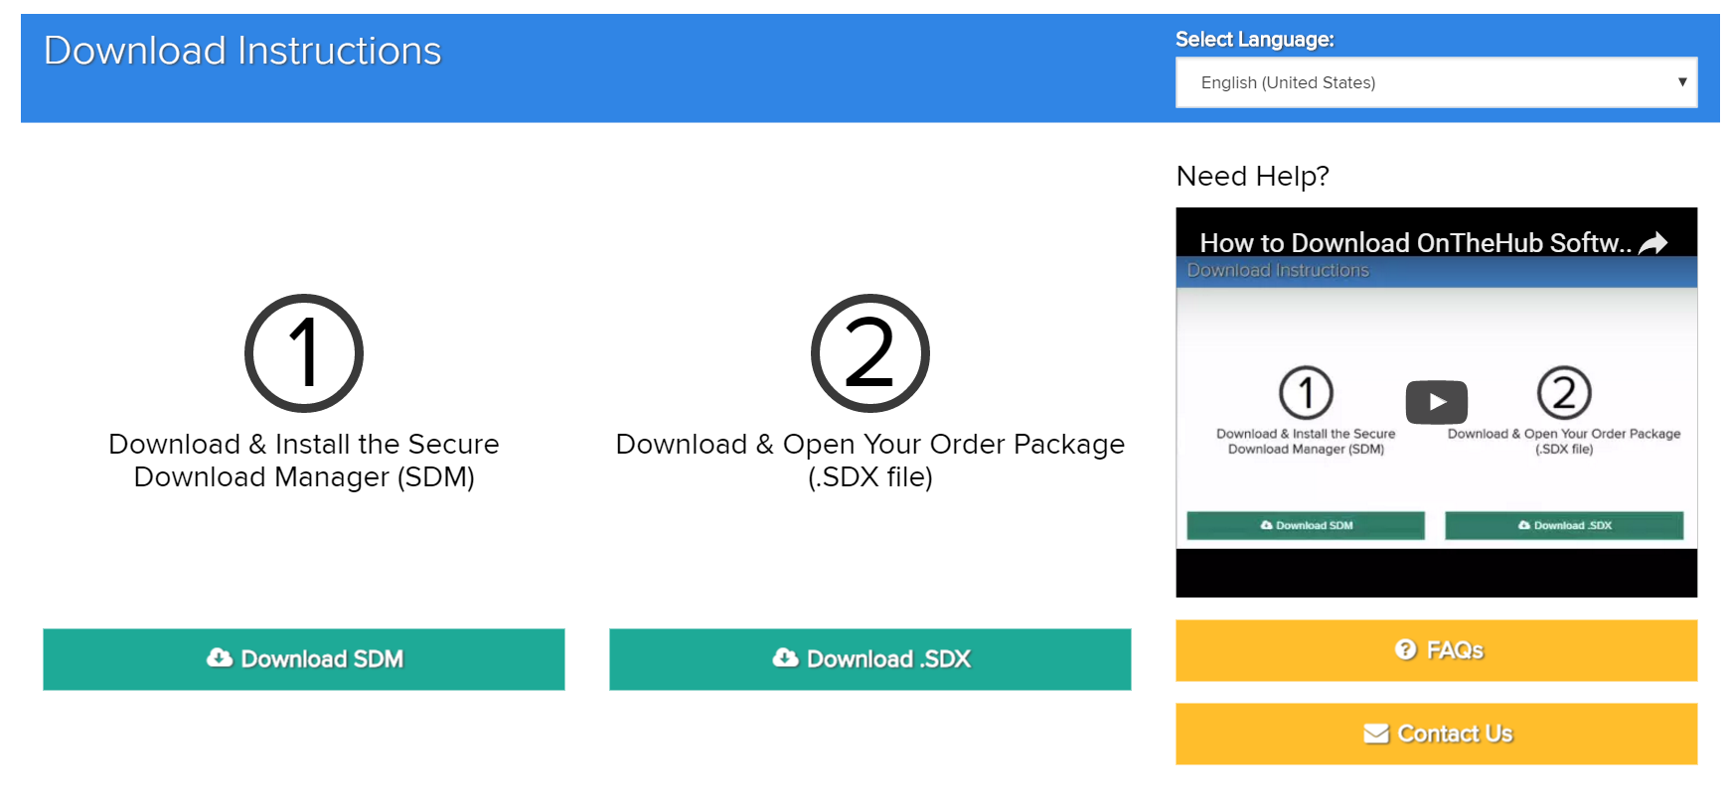

Open the .SDX file and Launch

Machine generated alternative text:
PASCO Capstone - InstallShieId Wizard 
PASCO Capstone requires the following items to be installed on your computer. Click 
Install to begin installing these requirements. 
Status Requiremen t 
Pending Microsoft Visual C ++ 2005 SP I Redistributable MFC Security Llpdate KE2538242(x86) 

Machine generated alternative text:
El PASCO Capstone 
- InstallShieId Wizard 
Welcome to the InstaUShield Wizard for 
PASCO Capstone 
The InstallShieId(R) Wizard will install PASCO Capstone on your 
computer. To continue, click Next. 
mscocapstone- 
WARNING : This program is protected by copyright law and 
internatonal treates. 
Next 

Machine generated alternative text:
PASCO Capstone - InstallShieId Wizard 
License Agreement 
Please read license agreement care frilly. 
IMPORTANT 
mscocapstone- k , 
Please carefully read the terms and conditions before installing and using the 
media for purposes other than product evaluation. installing the media, you 
accept the following terms and conditions of this End User License Agreement 
(EULA). If you do not agree with the terms, do not install the media. This License 
will be governed by the Laws of the State of California, United States of America. 
UPGRADE POLICY 
Media updates and revisions are promulgated either through the PASCO scientific 
website or other appropriate means. It is the responsibility of the end user to 
update media as needed. 
C) I accept the terms in the license agreement 
@I do not accept the terms In the license agreement 
InstallShieId 

Machine generated alternative text:
EJ PASCO Capstone - InstallShieId Wizard 
Click Next to install to this folder, or click 
Change to install to a different folder 
Install PASCO Capstone to: 
mscocapstone- 
C: Program Files (x86) FASCO scientficl 
InstallShieId 
Next 

Machine generated alternative text:
PASCO Capstone - InstallShieId Wizard 
Ready to Install the Program 
The Wizard is ready to begin installation. 
Click Install to begin the Installation. 
mscocapstone- 
If want to review or change any of your installation settings, click Back. Click Cancel to 
exit the wizard. 
InstallShieId 

Machine generated alternative text:
EJ PASCO Capstone - InstallShieId Wizard 
Installing PASCO Capstone 
Selected features are being installed. 
mscocapstone 
Please wait while the InstallShieId Wizard Installs PASCO Capstone. This may 
take several minutes. 
Status: 
Installing PASCO common resources 
InstallShieId 

Machine generated alternative text:
El PASCO Capstone 
- InstallShieId Wizard 
InstaUShield Wizard Completed 
The InstallShieId Wizard has successffly installed PASCO 
Capstone. Click Finish to exit the Wizard. 
mscocapstone- 
Your Internet connecton can be used to make sure that you 
have the latest updates. 
Show the Windows Installer log 

Machine generated alternative text:
untit'Ed,cep 
File Edit Workbook Display 
Journal 
Page 
Record 
Help 
Text & Graph 
Four Displays 
Setup 
Displays X 
Gra ph 
H i stogram 
Digits 
Text Box 
Text Entry Box 
C o ntro Is 
Drag a display onto the page or choose one of the QuickStart templates below. 
Table & Graph 
Two Displays 
oo:oo.oo 
Conti 
PASCO Capstone 
mscocapstonew 
PASCO Capstone 
Version: 1 _6_0 
Thank you for using the trial versiom You 
have until Sat Aug 2018 before the license 
expires 
Close 
Common Rate 
Copyright 2018 PASCO Scientific All Rights Reserved 
Reco rd ing 
Comditions 
Buy Key Enter Key 
Delete Last 

Machine generated alternative text:
PASCO Capstone 
Enter Key 
ne 
Please enter the product key found on the CD 
case, or paste it in from the email you received 
when you purchased the sot.'.'are. 
18jkm-suot7-Ef011-jS80b-20qrs-c89331 
PASC 
Status: PASCO Capstone Site License 
Cancel 
versiom You 
fore the license 
Close 
Copyright 2018 PASCO Scientific All Rights Reserved 
Buy Key Enter Key 

Capstone is now fully loaded.

By double clicking on a Capstone file (\*.cap), Capstone will automatically open

Machine generated alternative text:
Untitled.cap 
File Edit Workbook Display 
Journal 
Page 
Help 
Text & Graph 
Four Displays 
Setup 
Displays X 
Gra ph 
H i stogram 
Digits 
Text Box 
Text Entry Box 
C o ntro Is 
Drag a display onto the page or choose one of the QuickStart templates below. 
Record 
Table & Graph 
Two Displays 
oo:oo.oo 
Conti 
Graph & Dgits 
One Small, One Large 
Display 
Common Rate 
Reco rd ing 
Comditions 
Two Large Digits 
Two Small, One Large 
Display 
Delete Last 

You can also open a file by clicking on the Open Experiment icon circled above.