**Objective:**

The objective of this exercise is to use video and video analysis software to measure the motion of objects. The first two videos will be of a falling ball and falling balloon. You will use these videos to observe the effect of air resistance of an object in free fall. The third video will allow you to understand the experimental basis for describing projectile motion as the superposition (or combination) of motion in the vertical direction and in the horizontal direction.

**Parts and Equipment Required**:

* Computer with Internet and an iLAB link
* *Tracker.jar* video analysis software
* Three video files: *ball_drop.avi, balloon_drop.avi, Basketball.avi*

**Introduction:**

A projectile is an object moving in two dimensions under the influence of only the gravitational force. Near the Earth’s surface the gravitational force produces an acceleration that is nearly constant. This constant acceleration is called ***g*** and is approximately equal to 9.80 m/s2.

If air resistance (or drag) is small enough to be ignored than object’s such as basketballs and bullets can be considered projectiles when they are in the air. Because the direction of the acceleration due to gravity is vertically down, the **motion** of any projectile can be broken into two parts: a vertical piece that we will call *y* and a horizontal piece that we will label *x*. The motion in the vertical (*y*) direction can be described by the equations:



A position-time graph of the vertical motion will be a parabola and the velocity-time graph of the vertical velocity will be a straight line with slope −*g*. This is the same as if the object were simply thrown straight up. The motion in the horizontal (*x*) direction can be described by:



Air drag is negligible and the horizontal motion is the same as one-dimensional motion with zero acceleration. A plot of *x* versus *y* will show the object’s **trajectory** in space. Even though the object’s trajectory and vertical position-time graph will both be parabolas, it is important to realize that the two graphs describe different things.

Trying to measure a projectile’s motion using distance sensors would be extremely difficult, but a video of a projectile’s trajectory and the proper software will make the measurement easy. Any video (or movie for that matter) is a series of still photographs (frames) taken at precise time intervals. This time interval is called the frame rate of the video. If we could analyze a video frame by frame, we could build a trajectory of the object. With a coordinate system and a scale, we can then measure the position of the object in every frame and use the changes from frame to frame to calculate velocities and accelerations. ***Tracker*** (written by Douglas Brown of Cabrillo College) is software that will allow us to analyze a video file in this way. You will use Tracker to analyze three videos. Analyzing the first (*ball_drop.avi*) will give you a short tutorial on the software and give you a chance to confirm that the free fall acceleration due to gravity is approximately 9.8 *m*/*s*2, and that all objects in free-fall near the surface of the earth experience the same acceleration. Analysis of the second video (*balloon_drop.avi*) will enable you to see the effect of air resistance on a falling object. The third video (*basketball.avi*) will give you the opportunity to analyze the motion of a basketball in the air and determine its velocities and accelerations.

**Procedure:**

1. **Setup**

**Option 1**

* 1. Login into iLab at [www.lab.devry.edu](http://www.lab.devry.edu)
  2. Download the video files: *inelastic_equal_masses.mov, inelastic_blue500.mov, elastic_equal_masses.mov, elastic_red500.mov,* and *elastic_blue500.mov* to a folder on your computer.
  3. Use Windows Explorer to copy the files *inelastic_equal_masses.mov, inelastic_blue500.mov, elastic_equal_masses.mov, elastic_red500.mov,* and *elastic_blue500.mov* to the *F:* drive.
     1. Open Windows Explorer from the list of Apps
     2. Click on *Local Disk* and find the video files
     3. Highlight the video files, right click and copy (or ctrl-C)
     4. Click on *Computer* on the left side of the screen and then the F drive (F:)
     5. Open the Desktop file and paste the video file (ctrl-V)
  4. Close Explorer and open *Tracker* by clicking on the *Tracker* icon under Apps
  5. When Tracker opens explore the software and read the help file.

**Option 2 (recommended)**

* 1. Alternatively, you can download the tracker software and access the files directly from your local computer: <http://physlets.org/tracker/>
  2. Click the appropriate button near the top of the screen and the download will start automatically.



1. **Part 1 One dimensional freefall**
2. Use the open file tool button() to open *ball_drop.avi* from the F: drive or your computer
3. Play the video and then step through the video one frame at a time.
4. 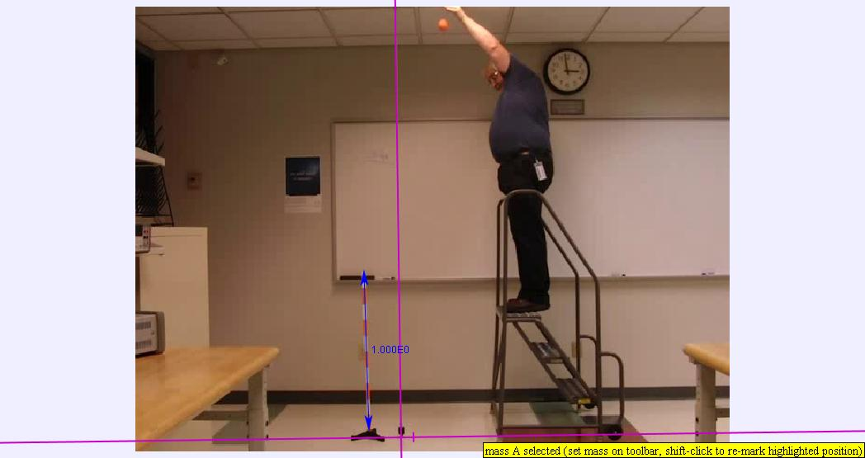At the first frame, create a calibration tape by clicking the calibration tool button(). Place the tape measure by dragging the ends to the edges of the meter stick on the left of the video. The tape measure initially reads number of pixels. Change the scale by double-clicking on the number and typing 1.00.

Figure 1 A frame of ball_drop.avi showing axes and scale

1. Display the axes by clicking the Axes button ( ). Drag the axes so that the origin is set at the point of the plumb bob as shown in **Figure 1**. Rotate the axes so that the y-axis aligns with the string. At this point your Tracker window should look like Figure 1.
2. Click on the Create button (). Create a new point mass marker. Advance the video frame by frame until you reach the frame where the ball is released. Carefully mark the position of the ball by holding the shift button while clicking the mouse. You may zoom in to get a more accurate position. The video should automatically advance to the next frame. Mark the next position of the ball. Repeat for until you have marked the ball in every frame until end of the video clip. As the ball starts to move faster there will be some motion blur that will make the center of the ball harder to find. Just be consistent in your choice from frame to frame.
3. 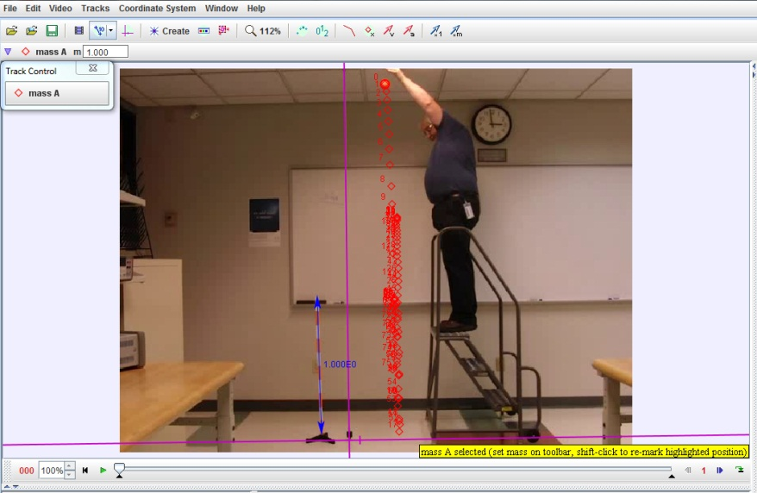The video should look like **Figure 2**. Play the video and notice that the tracks highlight in turn as the ball drop. You have just made a motion diagram of a falling object.

Figure 2 Ball_drop.avi with ball positions marked

1. Save your work to the F: drive as *ball_drop.trk*. or your computer
2. **Part 1 Analysis**
3. 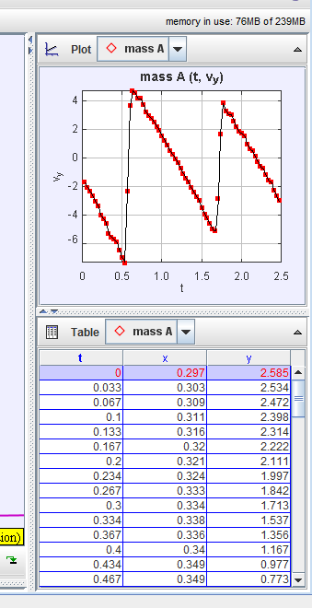Pull open the plot window as shown in **Figure 3**. Select Mass A (the ball).

Figure 3 velocity-time graph

1. Click on the y-axis label to change the variable to the velocity in the y-direction (*v*y).
2. Double-click on the graph to open the Data Tool window. Uncheck the line box. Check the Curve fits box and the Autofit box to analyze the velocity data. Drag your mouse to select just the data while the ball is in the air. Your result should look like **Figure 4**. The parameter *a* is the slope of the fit and the parameter *b* is the y-intercept. The slope of the velocity-time graph is the acceleration and should be within 10% or so of the expected value −*g* = 9.8 m/s2. Repeat the analysis for each of the three straight line sections of the graph. Record the slopes in the table provided on your data sheet. The data confirms what we have read about freefall. This shows that the ball is not significantly affected by air resistance and the projectile model is a good model for the motion of this object.
3. Paste a copy of your ball velocity data with one of the fits in the space provided on the data sheet. Save your work and close *ball_drop.trk*.

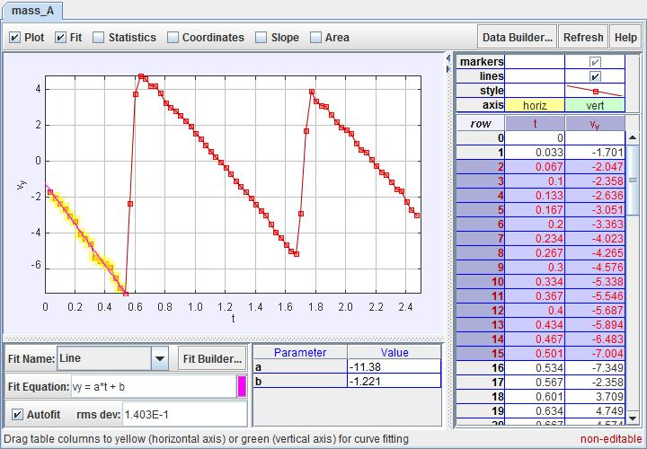

Figure 4 velocity-time graph with linear fit.

1. **Part 2 The Effect of Air Resistance**
   1. Open the file *balloon_drop.avi* from the tracker file menu.
   2. Set the scale marker and the axes just as you did with the lacrosse ball. The scale in this video is 2.00 metres.
   3. 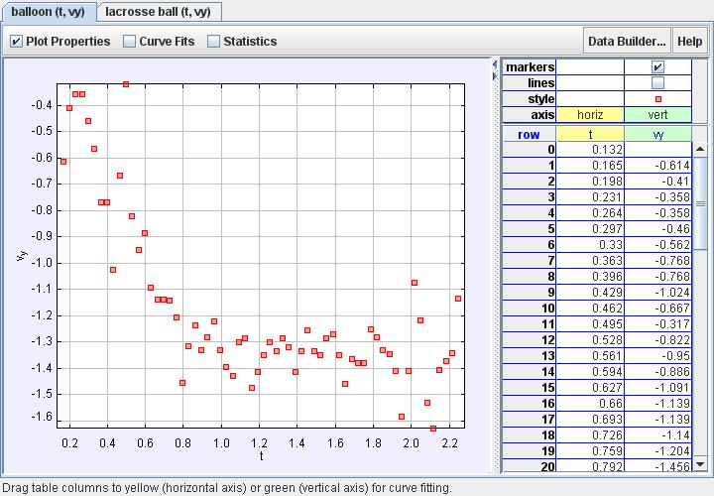Create a point mass marker and mark the center of the balloon for each frame until the balloon hits the floor. The balloon moves much more slowly than the ball. There will be no problem with motion blur.

Figure 5 velocity-time graph of falling balloon

1. **Part 2 Analysis**
   1. Go to the Plot window. Select Mass B (the balloon) and again select Vy.
   2. The vertical velocity data for the balloon is shown in **Figure 6**. The data does not lie on a straight line. In fact, by about 0.8 seconds the velocity of the balloon is essentially a constant. Something (perhaps air drag) must be changing the acceleration of the balloon. Clearly the projectile model does not work for the balloon. Use the Line fitting routine just as you did for the lacrosse ball and record the measured slope on the data sheet.
   3. Paste a copy of your balloon velocity data with your fit in the space provided on the data sheet. Save your work and close *balloon_drop.trk*.
2. **Part 4 Projectile Motion**
   1. Open the video *basketball.avi*.
   2. Play the video and step through it frame by frame until you have a good feel for the motion.
   3. Set the tape measure to the meter stick being held in the center of the frame and set the scale to 1.00 meters.
   4. Step through the video until the basketball is just released. Set the origin of the axes to the basketball at that point.
   5. Use the track control to mark the position of the basketball for each frame from release until it hits the rim. Your file should look similar to **Figure 6**. 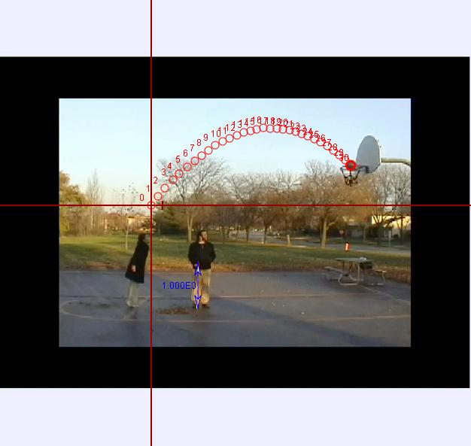

Figure 6 Basketball free throw with track

* 1. Use the Data Tool to make straight line fits of the vertical velocity (Vy) and the horizontal velocity (Vx) Paste each graph on the data sheet in the appropriate places and answer the questions.
  2. Examine the *y*-time graph to find the time at which the basketball is at the highest point in its trajectory.
  3. Find the value of the vertical velocity at the time when the basketball is at its peak. Answer the questions.
  4. Save your file as *basketball.trk*.
  5. Copy the data sheet to your local drive and turn in a copy to your instructor.