Week 1: Lab (Car Loan Analysis)
Scenario/Summary:
The best way to understand the advantages of using a model is to actually create one and to understand theory of the model. This assignment will help you create a model using a spreadsheet and understand its theory completing the task below.
- Using a minimum of three academic sources of research, prepare a minimum of three-pages covering theory behind descriptive, predictive, and prescriptive modeling techniques and their uses to support various decision making efforts.

- In the conclusion of this paper, you will reference and apply understanding on whether the model you create below is descriptive, predictive, or prescriptive in nature defending your claims.

- Once paper is complete with exception to the conclusion, create the following car loan analysis worksheet following starting with Step 4 below.

- Open a new Microsoft Excel workbook, and rename any sheet tab of choice to Car Loans.

- Use the illustration and further steps below to set up and format your worksheet

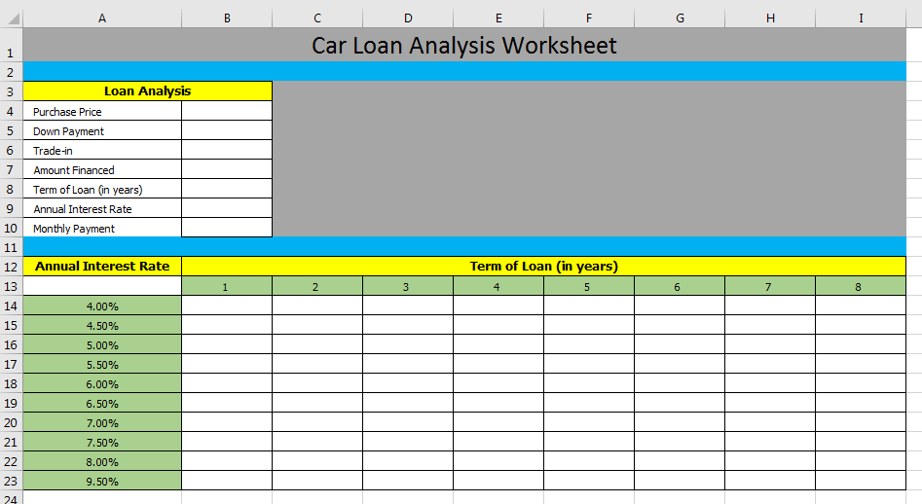

- Merge and center cells A1 and I1, and then enter a title Car Loan Analysis Worksheet.

- Then from cell A4 through A10, enter the following labels.
  - Purchase Price
  - Down Payment
  - Trade-in
  - Amount Financed
  - Term of loan (in years)
  - Annual Interest Rate
  - Monthly Payment

- Then from cell B4 through B6, enter a purchase price, down payment, and trade-in value of choice. Then create a formula to calculate amount financed in cell B7.

- Then from cell B8 through B9, enter the term of loan in years and an interest rate of choice. Then use a PMT function to determine the monthly payment in cell B10.

- In cell A13, equal this to cell reference B10.

- Starting with cell A14 and ending with A23, enter some interest rates.

- Starting with cell B13 through I13, enter some additional term of loan options in years.

- Using your mouse, select all cells in the range from A13 through I23. Then select the data tab and then the What-If-Analysis tool. From the What-If-Analysis options, select Data Table. At this point, a small dialog window will appear asking for Row and Column input cells. For the Row Input, select the value associated with years in the loan which would be an absolute reference as $B$8. For the Column Input, select the value associated with interest rate which would be an absolute reference as $B$9. Note: To get a better understanding of the purpose and uses of the What-If-Analysis, be sure to explore www.youtube.com and the keywords Microsoft Excel What-If-Analysis Data Tables to see additional demonstrations.

- Once all data and calculations are working, do any other housekeeping to include professional format of choice to enhance presentation of data.

- Save your work to a secure location. Name the assignment file Week_1_Lab and integrate into your conclusions by example on whether this model is descriptive, predictive, or prescriptive in nature defending your claims.

- Once all is ready to submit for grading, carefully review the Grading Rubric as a checkpoint of requirements, and then submit both your completed APA formatted paper and Excel Workbook to the designated Dropbox.

Week 1: Lab (Grading Rubric)

Category | Description | Points Earned
Topic Selection | The topic clearly identifies descriptive, predictive, and prescriptive modeling techniques. | 5/5
Bibliography | The bibliography includes at least three references. References are authoritative and do not include anonymous authors. Web pages, if used, are clearly written by experts in the field (expert qualifications are given in the summaries). At least three references are peer-reviewed, scholarly papers. The bibliography is in APA format and is free of typographical, grammar, spelling, and formatting errors. | 5/5
Paper: Formatting | The paper is in 12-point Times New Roman font, double-spaced, and includes a cover page, table of contents, introduction, body of the report, summary or conclusion, and references. The Final Paper conforms to APA format. | 5/5
Paper: Organization and Cohesiveness | The paper includes an introduction that generates interest in the topic and previews the main points to be covered, a body that develops each main point, and a conclusion that summarizes the main points covered. There is a logical flow of ideas throughout the paper. There is a clear thesis statement for the paper and a clear topic statement for each major section. Appropriate transitions are used between topics and subtopics. | 5/5
Paper: Editing | The paper uses a professional writing style and is free of typographical, spelling, and grammar errors. | 5/5
Paper: Content | The paper is of the required length and fully addresses topics provided. Topics should include descriptive, predictive, and prescriptive modeling techniques. Examples and supporting details are provided for each main point. Authoritative sources are cited as support. The paper is at least 80% in the student’s own words (i.e., no more than 20% direct quotations from a source). | 35/35
Excel: Technology | Car Loan Analysis Worksheet created and is accurate with proper use of formulas and functions and is professionally formatted. Determinations of descriptive, predictive, or prescriptive modeling is integrated into conclusions of paper based on this analysis worksheet. | 30/30
Total | A quality paper will meet or exceed all of the above requirements. | 90/90
Comments

