Week 5: Lab (Pay Off Matrix and Decision Trees)
Scenario/Summary:
In the realm of business, there are many options to help managers and leaders develop good decisions based on data analysis outcomes and associated risk. One important option and tool in this case is a decision tree. Decision trees are ideal when there are cases of many possible outcomes. They provide an organized structure, which allows managers and leaders to examine these available results while making decisions based on the options provided from the outcomes. In other words, a decision tree is like a visual map of potential roadways for actions to take.
- To further learn the theory of using decision trees, use a minimum of three academic sources of research and prepare a minimum of three pages covering how decision trees are developed and how decision trees help in the decision-making process. Furthermore, include coverage of how the maximax, maximin, minimax regret, EMV, EOL decision rules, the expected value of perfect information (EVPI), and expected value of imperfect information (EVII) are used to support the development and output of decision trees.

- In the conclusion of this paper, you will reference and apply understanding based on the completion of question 13 on pages 798 and 799 (The Tall Oaks Wood Products Company).

- To complete this case, open a new workbook and name the file Week_5_Lab_StudentName.xlsx. In the workbook, create seven worksheets with the sheet names, including

  - payoffs;
  - maximax;
  - maximin;
  - minimax regret;
  - expected value;
  - expected regret; and
  - decision tree.

- When working through the series of steps below, be sure to refer to the chapter readings of the week for further demonstrations working with payoff matrixes and decision trees.

- For the base data of the Payoffs worksheet, refer to the illustration below, and this worksheet is just data more so than a refernece.
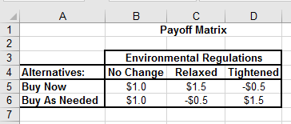

- For the Maximax worksheet, refer to the illustration below and cells marked in yellow need functions. For example, the function for cell E5 would be =MAX(B5:D5) and cell F5 would be =IF(E5=MAX($E$5:$E$6),"<--maximum",""). Use similar and required functions for cells E6 and F6.

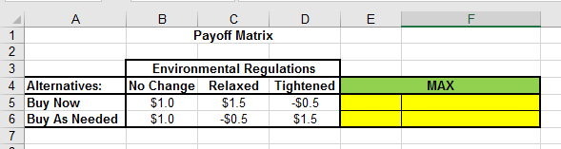
- For the Maximin worksheet, refer to the illustration below and cells marked in yellow need functions. For example, the function for cell E5 would be =MIN(B5:D5) and cell F5 would be =IF(E5=MAX($E$5:$E$6),"<--maximum",""). Use similar and required functions for cells E6 and F6.
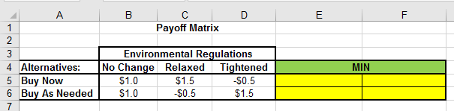
- For the Minimax Regret worksheet, refer to the illustration below and cells marked in yellow need functions. For example, the function for cell E5 would be =MIN(B5:D5) and cell F5 would be =IF(E5=MAX($E$5:$E$6),"<--minimum",""). Use similar and required functions for cells E6 and F6.
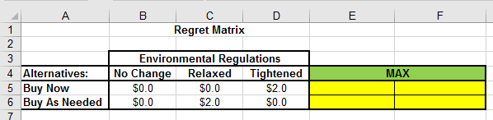
- For the Expected Value worksheet, refer to the illustration below and cells marked in yellow need functions. For example, the function for cell E5 would be =SUMPRODUCT($B$8:$D$8,B5:D5) and cell F5 would be =IF(E5=MAX($E$5:$E$6),"<--maximum",""). Use similar and required functions for cells E6 and F6. Also, note that probability values can be determined from the written problem.
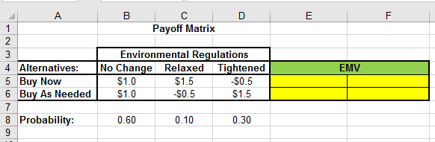
- For the Expected Value worksheet, refer to the illustration below and cells marked in yellow need functions. For example, the function for cell E5 would be =SUMPRODUCT($B$8:$D$8,B5:D5) and cell F5 would be =IF(E5=MIN($E$5:$E$6),"<--minimum",""). Use similar and required functions for cells E6 and F6. Also, note that probability values can be determined from the written problem.
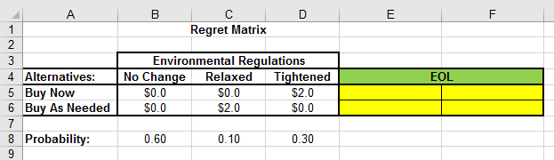
- Now based on the data collected from the payoff matrix, design a decision tree for this case. It should be noted that there are drawing tools located in Microsoft Excel with the illustrations tool; however, everyone may find the Analytic Solver Platform useful to create this decision tree.

- Now for the conclusion of the paper and based on output and results produced through the payoff matrix and decision tree, reflect in descriptive details, correlating back to your research, your thoughts and professional opinions on how well these tools can be used to support the decision-making process and compare these options with other decision-making choices already learned in the class.

- Save both your assignment files in Microsoft Word and Excel, and name the files Week_5_Lab_StudentName.docx and Week_5_Lab_StudentName.xlsx.

- Submit both the Microsoft Word and Microsoft Excel assignment files to the Week 5 Lab Dropbox.

Week 5: Lab (Grading Rubric)
Category | Description | Points Earned
Topic Selection | The topic clearly identifies uses and development of decision trees and how they are supported. | 5/5
Bibliography | The bibliography includes at least three references. References are authoritative and do not include anonymous authors. Web pages, if used, are clearly written by experts in the field (expert qualifications are given in the summaries). At least three references are peer-reviewed, scholarly papers. The bibliography is in APA format and is free of typographical, grammar, spelling, and formatting errors. | 5/5
Paper: Formatting | The paper is in 12-point Times New Roman font, double-spaced, and includes a cover page, table of contents, introduction, body of the report, summary or conclusion, and references. The Final Paper conforms to APA format. | 5/5
Paper: Organization and Cohesiveness | The paper includes an introduction that generates interest in the topic and previews the main points to be covered, a body that develops each main point, and a conclusion that summarizes the main points covered. There is a logical flow of ideas throughout the paper. There is a clear thesis statement for the paper and a clear topic statement for each major section. Appropriate transitions are used between topics and subtopics. | 5/5
Paper: Editing | The paper uses a professional writing style and is free of typographical, spelling, and grammar errors. | 5/5
Paper: Content | The paper is of the required length and fully addresses topics provided. Topic areas should include the theory covering how decision trees are developed and how decision trees help in the decision-making process, including coverage of data analysis techniques used to support the creation of such decision trees. The paper is at least 80% in the student’s own words (i.e., no more than 20% direct quotations from a source). | 35/35
Excel: Technology | Microsoft Excel is used properly in the creation of one workbook with seven worksheets included to support the payoff matrix and creation of the decision tree along with proper use of formulas and functions. | 30/30
Total | A quality paper will meet or exceed all of the above requirements. | 90/90
Comments

