Week 6: Lab (LP Modeling and Optimal Solutions)
Scenario/Summary:
In the realm of business, business manages and leaders are always looking for optimal solutions to help in the decision-making process. During Week 2, everyone explored Linear Programing (LP) models to create sensitivity analysis reports. LP models can do much more to help mangers and leaders also find optimal solutions but as current or future managers and leaders, we must be aware that some optimal solutions given certain cases may be out of our reach for the given conditions or work environment.
- To go further into the theory of using Linear Programing (LP) models, use a minimum of three academic sources of research, and prepare a minimum of three pages covering situations and examples of how LP models can find optimal solutions. Also, address how managers and leaders would handle LP models that have more than one optimal solution and where optimal solutions are out of range or not feasible.

- In the conclusion of this paper, you will reference and apply understanding of Linear Programing (LP) models while finding the optimal solution to the case, beginning with Step 3.

- DeVry University Peanut Company sells peanuts and makes all sorts of flavors to satisfy a wide range of customers. Getting ready for a new year, the president of marketing estimated the company can sell the following case quantities with extra cases supported with marketing.

Peanut Flavors | # of Cases | Extra Cases sold for Every Dollar Spent on Marketing
Peanut Butter and Jelly | 5,000 | 10 Extra Cases
Mozzarella | 1,000 | 2 Extra Cases
Honey | 5,000 | 10 Extra Cases
Sour Cream and Onion | 7,500 | 14 Extra Cases
Dill Pickle | 6,000 | 11 Extra Cases
Ranch and Bacon | 2,400 | 3 Extra Cases
Salt and Pepper | 1,500 | 3 Extra Cases
Jalapeno | 500 | 2 Extra Cases
Barbecue | 12,000 | 10 Extra Cases
Firehouse | 1,000 | 4 Extra Cases
Inferno | 250 | 2 Extra Cases
Strawberry | 9,000 | 13 Extra Cases

- All flavors, by each case, when sold to consumers, vendors, or customers is $20.00; however, each flavored peanut has varied production cost illustrated in the table below.

Peanut Flavors | Production Cost
Peanut Butter and Jelly | $ 5.00
Mozzarella | $ 6.50
Honey | $ 11.00
Sour Cream and Onion | $ 4.00
Dill Pickle | $ 4.25
Ranch and Bacon | $ 4.75
Salt and Pepper | $ 5.88
Jalapeno | $ 9.41
Barbecue | $ 4.86
Firehouse | $ 8.88
Inferno | $ 7.77
Strawberry | $ 5.55

- The president of the DeVry University Peanut Company wants to make sure the company manufactures at least the minimum amounts of each peanut flavor based on estimates by the president of marketing.

- The company’s financial department has allocated and approved a budget of $225,000 for advertising, and a minimum of $7,500 must be spent advertising each flavored peanut.

- Based on the information from above, we need to determine how many cases of each peanut flavor should be produced, along with suggestions to allocate money for advertisements to maximize profits.

- To do this, open a new workbook, and name the file Week_6_Lab_StudentName.xlsx. In the workbook, rename the default worksheet to “Flavored Peanut Production & Ad.” Use the illustration below as a guide to prepare and format your LP model.

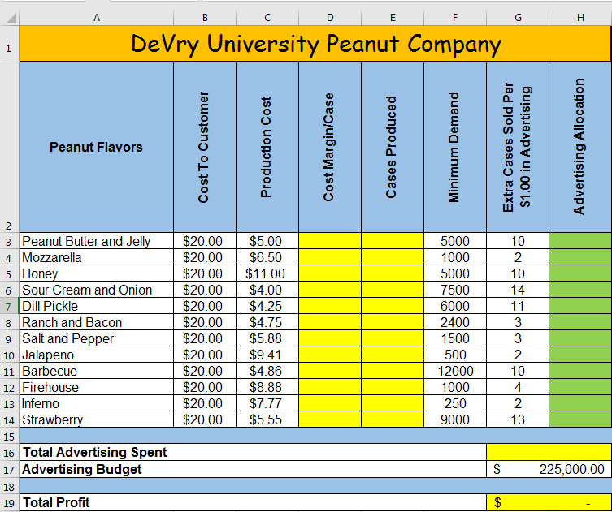

- Now, that the Linear Programming (LP) model is set up, be sure the Solver add in is installed in Microsoft Excel, and the Excel application in Citrix already has this feature installed. This is a free add-in, and if you’re using a personal copy of Microsoft Excel, see the directions below from Microsoft.

Microsoft, (2016). Load the solver add-in: Applies to Excel 2013 and 2016. Retrieved from https://support.office.com/en-us/article/Load-the-Solver-Add-in-ec994cd0-a396-4bf3-a5dd-feda369cef37 . Files are located in Course Home Course Resources.

- Once solver is installed, this tool can be accessed through the Data tab.

- Once activated, your goal is to find the optimal solution, which in this case, is to find maximum profit selling flavor peanuts.

- Before using the model, yellow shaded areas in the LP model illustration will need formulas.

  - Cost Margin/Case can be calculated: (cost to customer) – (production cost)
  - Cases Produced can be calculated: (minimum demand) + (extra cases sold per $1.00 in advertising) * (advertising allocation)
  - Total Advertising Spent can be calculated by adding up all (advertising allocation)
  - Total Profit can be calculated by adding up all products from (cost margin/case) and (cases produced) minus the (advertising budget). Hint: Use SUMPRODUCT(array1,array2) – H17

- Once all formulas are in place, activate the Solver tool, and the “Set Objective” will be total profit.

- The “By Changing Variable Cells” will be all cells from H3 through H14—the green highlighted cells in the illustration. These are the cells with purpose for manipulation.

- There are two primary constraints, and the first constraint is the adverting constraint. The left side of the constraint will be used for total advertising spent and the right side will be advertising budget. Because total advertising spent cannot exceed the advertising budget, we want to use the less than or equal to operator.

- The second constraint is also based on advertising, where each flavored peanut must have a minimum of $7,500. This constraint will include each value in the range from H3 through H14 on the left, which is greater than or equal to $7,500 on the right of the constraint input.

- Once all constraints are entered, check if needed “Make Unconstrained Variables Non-Negative.” For the solving method, use Simplex LP and click “Solve,” and it is recommended to include all available reports, including answer, sensitivity, and limits. Below is an additional illustration for the input of all constraints.

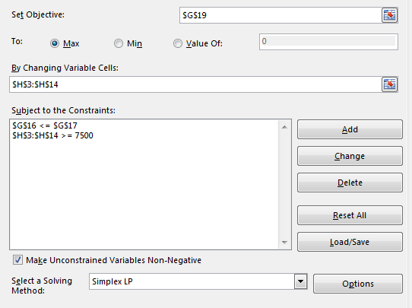

- Although not required for this case, it is again recommended to comprise all available reports, including answer, sensitivity, and limits.

- Run the LP model again two or three times, changing some of the values each time with production cost and extra cases sold for every dollar spent on advertising. Also, be welcome to adjust the advertising budget.

- Now with the provided reports, are the optional solutions, although different, similar, and if so, would you trust this solution for allocating funds toward advertisements of each individual flavored peanut? If not, what would you propose when advertising the flavored peanuts knowing that the LP model has found an optional solution for maximum profit.

- Integrate your reflections and decisions into the conclusions of the main paper, showing correlation based on what you learned from both your research and application of LP models to find optimal solutions.

- Save both your assignment files in Microsoft Word and Excel, and name the files Week_6_Lab_StudentName.docx and Week_6_Lab_StudentName.xlsx.

- Submit both the Microsoft Word and Microsoft Excel assignment files to the Week 6 Lab Dropbox.

Week 6: Lab (Grading Rubric)
Category | Description | Points Earned
Topic Selection | The topic clearly identifies and goes further into the realm of Linear Programming (LP) models. | 5/5
Bibliography | The bibliography includes at least three references. References are authoritative and do not include anonymous authors. Web pages, if used, are clearly written by experts in the field (expert qualifications are given in the summaries). At least three references are peer-reviewed, scholarly papers. The bibliography is in APA format and is free of typographical, grammar, spelling, and formatting errors. | 5/5
Paper: Formatting | The paper is in 12-point Times New Roman font, double-spaced, and includes a cover page, table of contents, introduction, body of the report, summary or conclusion, and references. The Final Paper conforms to APA format. | 5/5
Paper: Organization and Cohesiveness | The paper includes an introduction that generates interest in the topic and previews the main points to be covered, a body that develops each main point, and a conclusion that summarizes the main points covered. There is a logical flow of ideas throughout the paper. There is a clear thesis statement for the paper and a clear topic statement for each major section. Appropriate transitions are used between topics and subtopics. | 5/5
Paper: Editing | The paper uses a professional writing style and is free of typographical, spelling, and grammar errors. | 5/5
Paper: Content | The paper is of the required length and fully addresses topics provided. Topic areas should include theory of how situations and examples of LP models can find optimal solutions also addressing how managers and leaders would handle LP models that have more than one optimal solution and those where optimal solutions are out of range or either not feasible. The paper is at least 80% in the student’s own words (i.e., no more than 20% direct quotations from a source). | 35/35
Excel: Technology | Microsoft Excel is used properly to create a Linear Programming (LP) model using proper formulas and functions along with proper use of model constraints. | 30/30
Total | A quality paper will meet or exceed all of the above requirements. | 90/90
Comments

