Week 2: Lab (DeVry University Welcome Packets)
Scenario/Summary:
In the realm of business, organizations are always looking for the most cost effective ways to operate. In this effort, there will always be a certain level of uncertainty depending on each case; however, organizations are able to use sensitivity analysis methods using assumptions and estimates view expected results. These expected results, although not perfect, can help senior management and leadership of organizations to make decisions and changes where needed. To further explore the theory and application of sensitivity analysis, complete the steps below.
- Using a minimum of three academic sources of research, prepare a minimum of three pages covering theory behind sensitivity analysis techniques and their uses to support various decision-making efforts. To get you started in the right direction, common areas of sensitivity analysis would include partial sensitivity analysis, best-case and worst-case scenarios, and break-even analysis.

- In the conclusion of this paper, you will reference and apply understanding toward a sensitivity analysis model created as a foundation to develop decisions and to evaluate whether the model created is a good decision-making tool for the case below.

DeVry University is seeking to warmly welcome all entry point students with prepared welcome packets for all Texas locations, including the Austin, Irving, and San Antonio Campuses and the Mesquite Center. Distributors of these welcome packets are located in New York, California, and Missouri. In a normal quarterly cycle when new students are enrolled, the New York distributor can prepare 1,000 welcome packets, California distributor can prepare 1,750 welcome packets, and Missouri distributor can prepare 1,250 welcome packets. The cost of preparing and supplying each welcome packet is listed in the table below.

 | Austin Campus | Irving Campus | San Antonio Campus | Mesquite Center
New York | $22.50 | $20.50 | $24.75 | $21.85
California | $31.75 | $28.00 | $34.90 | $33.00
Missouri | $17.50 | $15.50 | $18.00 | $17.00

DeVry University has just received notice and verification of new enrolments list below and wants to determine the least costly plan for filling the required order of welcome packets for new entry point students.

 | New Enrollments
Austin Campus | 643
Irving Campus | 555
San Antonio Campus | 2077
Mesquite Campus | 704

- Once paper is complete with exception to the conclusion, create the following linear programming (LP) model based on the case above creating a new Microsoft Excel workbook naming the first sheet Welcome Packet Shipping.

- Use the illustration below as a guide to set up and format the linear programming (LP) model.
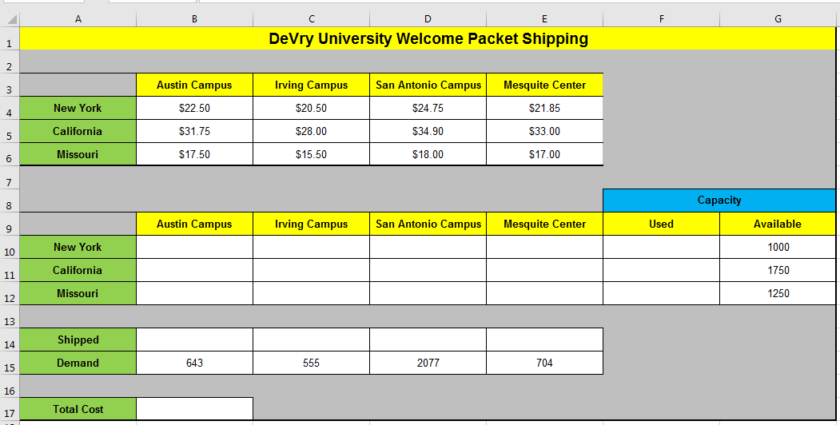

- In cell B17 based on the illustration above, place an optimization function: =SUMPRODUCT(B4:E6,B10:E12) and the goal of this function is to output the optimal and or lowest cost to ship welcome packets.

- In cells, B12 through E12, include a function to total welcome packets to be shipped. For example, the function in cell B12 will be: =SUM(B10:B12).

- In cells, F10 through F12, include a function to total welcome packets used by distributor location. For example, the function in cell F10 will be =SUM(B10:E10).

- Now, that the linear programming (LP) model is setup, be sure the Solver add in is installed in Microsoft Excel and the Excel application in Citrix already has this feature installed. This is a free add-in and if using a personal copy of Microsoft Excel, see the directions below from Microsoft.

Microsoft, (2016). Load the solver add-in: Applies to Excel 2013 and 2016. Retrieved from https://support.office.com/en-us/article/Load-the-Solver-Add-in-ec994cd0-a396-4bf3-a5dd-feda369cef37

- Once solver is installed, this tool can be accessed through the Data tab.

- Once activated, your goal is to find the optimal solution, which is the case is the lowest possible cost to ship all welcome packets to the four campus locations from the three distribution sites.

- The Set Objective will be total cost.

- The By Changing Variable Cells will be all cells from B10 through E12. These are the cells with purpose for manipulation.

- There are two primary constraints and the first constraint is the supply constraint. The left side of the constraint will be used for shipped welcome packets, and the right side will be availability. Because the number of needed welcome packets is currently less than availability, we want to use the less than or equal to operator.

- The second constraint is based on demand, the left side will be shipped, the left side of the constraint will be demand, and because there are enough welcome packets to cover all campuses, the equal operator should be used.

- Check if needed Make Unconstrained Variables Non-Negative and for the solving method, use Simplex LP and click Solve.

- Select all possible reports, including Answer, Sensitivity, and Limits.

- Run the scenario again where the California distributor faced issues with labor and materials and was only able to produce 500 welcome packets during the enrolment cycle. Tip: When running this second scenario, the same constraint areas will be used, but remember that depending on conditions, the operators between the left and right side of the constraints may need to be changed. Again in this case, select all possible reports, including Answer, Sensitivity, and Limits

- Now with the provided reports, review them and reflect upon them as if you were a manager using this information to make decisions.

- After reflecting and reviewing reports created based on both cases, how well does the solver tool in Microsoft Excel work to give information based on sensitivity analysis techniques if this were a real case where you had to make decisions on how distributors send welcome packets to DeVry University Texas campuses. How would you handle the second case where enough welcome packets are not available?

- Integrate your reflections into the conclusions of the main paper showing correlation based on what you learned from both your research and application of sensitivity analysis.

- Save both your assignment files in Microsoft Word and Excel and name the files Week_2_Lab following by your first and last name initials. For example, the file name for John Doe would be Week_2_Lab_JD.

- Submit both the Microsoft Word and Microsoft Excel assignment files to the Week 2 Lab Dropbox.

Week 2: Lab (Grading Rubric)
Category | Description | Points Earned
Topic Selection | The topic clearly identifies various sensitivity analysis techniques. | 5/5
Bibliography | The bibliography includes at least three references. References are authoritative and do not include anonymous authors. Web pages, if used, are clearly written by experts in the field (expert qualifications are given in the summaries). At least three references are peer-reviewed, scholarly papers. The bibliography is in APA format and is free of typographical, grammar, spelling, and formatting errors. | 5/5
Paper: Formatting | The paper is in 12-point Times New Roman font, double-spaced, and includes a cover page, table of contents, introduction, body of the report, summary or conclusion, and references. The Final Paper conforms to APA format. | 5/5
Paper: Organization and Cohesiveness | The paper includes an introduction that generates interest in the topic and previews the main points to be covered, a body that develops each main point, and a conclusion that summarizes the main points covered. There is a logical flow of ideas throughout the paper. There is a clear thesis statement for the paper and a clear topic statement for each major section. Appropriate transitions are used between topics and subtopics. | 5/5
Paper: Editing | The paper uses a professional writing style and is free of typographical, spelling, and grammar errors. | 5/5
Paper: Content | The paper is of the required length and fully addresses topics provided. Topic areas should include partial sensitivity analysis, best-case and worst-case scenarios, and break-even analysis as supported by sensitivity analysis. Examples and supporting details are provided for each main point. Authoritative sources are cited as support. The paper is at least 80% in the student’s own words (i.e., no more than 20% direct quotations from a source). | 35/35
Excel: Technology | Welcome Packet Shipping worksheet created and is accurate with proper use of formulas and functions and is professionally formatted. Use of solver to create sensitivity reports to find the lowest or optimal cost are present for both cases with a total of six reports in addition to the main worksheet. | 30/30
Total | A quality paper will meet or exceed all of the above requirements. | 90/90
Comments

