Creating a Zip File

If you need to submit multiple files to the Dropbox, it is easiest to create a zip file and upload all of the files at one time. A zip file is a special file that allows you to compress and combine folders into one file, which is easier and faster to transmit – through the Dropbox or through email.

STEP 1: Go to Windows Explorer by right-clicking on the Start button (or the Windows button in Vista):

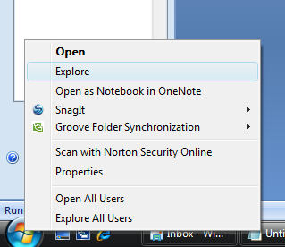

Step 2: Locate the folder in which you files are stored. In this example, I have the files for Lab 4 stored in My Documents 🡪 BIS155 🡪 Lab 4:

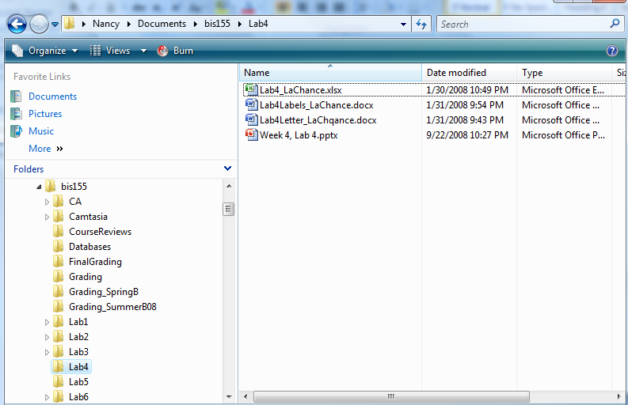

STEP 3: Select each of the files you want to include in your zip file. Select the first one, hold the CTRL key, and then select all of the other files:

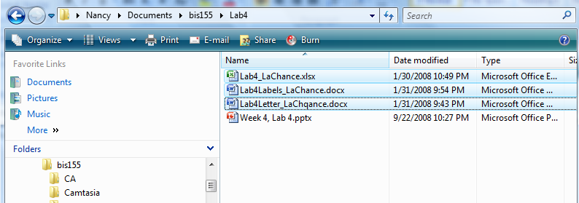

STEP 4: In Vista, right-click on the selected files. Click Send to and then click Compressed folder:

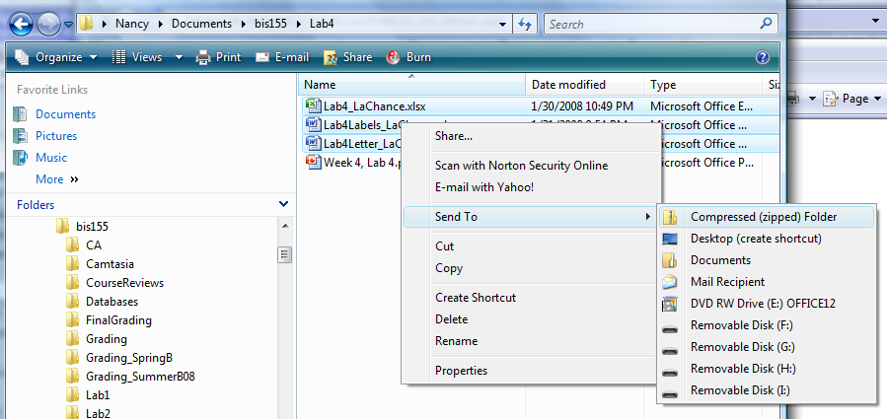

In Windows XP, click on the File menu and then select Send To and Compressed (zipped) Folder:

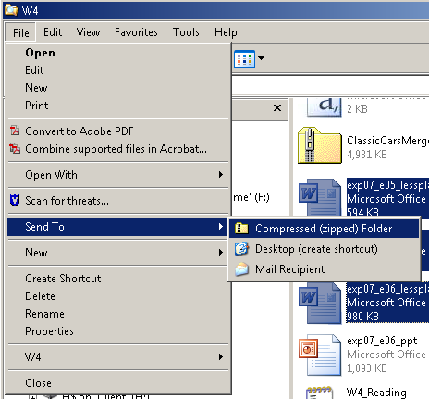

You will now have a new folder with a “.zip” extension that contains all of the files you have selected.

