MATH221, Week 4
Introduction to normal distributions

Description of normal distributions
Normal distributions, also called normal probability distributions, are bell shaped, symmetrical distributions. In these distributions, the probability of a specific outcome increases and then decreases at about the same rate. Normal distributions are distributions of continuous variables. A normal distribution looks like this:
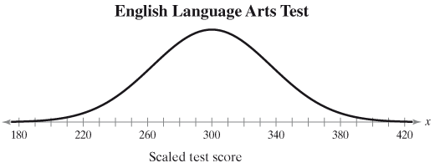
This distribution represents the test scores for all the students in a university. Among all the students, a few students scored as low as about 180, while many students scored about 300, near the highest point of the graph. Finally, a few students scored about 420. Remember that the height of the graph means frequency or higher probability.

Both the distributions below, A and B, are normal distributions. Since distribution A is shifted to the right, the values in that distributions are higher or larger than those in distribution B. Therefore, the mean of distribution A is higher than the mean of distribution B. The mean of a normal distribution is based on the position of the middle or high point of the distribution.

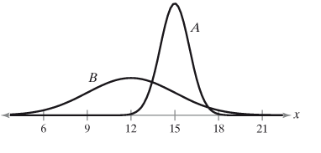
On the other hand, distribution B has the larger standard deviation as its values are more spread out or disperse than those in distribution A. The shape reflects the standard deviation.

Area and Probability
The total area under the normal distribution, of course reflects 100% of the area. The area is related to the probability. In the picture below, values of x less than -0.24 have a probability of 0.4052 occurring. The blue shared area shown below reflects 0.4052 or 40.52% of the total area under the curve.
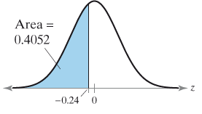
Unusual Events
The text uses the definition of less than 5% as being an unusual event. This is a common measure to use. Based on this definition, any event with a less than 5% chance of occurring would be considered an unusual event.

