MATH221, Week 4
Normal probabilities and the Empirical Rule

Empirical Rule
As a quick reminder, the Empirical Rule only applies to normally distributed data and has three parts.
* 68% of data are within 1 standard deviation of the mean
* 95% of data are within 2 standard deviations of the mean
* 99.7% of data are with 3 standard deviations of the mean

These probabilities could be considered within any normal distribution. For example, if a normal distribution had a mean of 50 and a standard deviation of 4, then what percent of data would be expected to fall between 46 and 54? The range of 46 to 54 is within one standard deviation of the mean. The week 4 spreadsheet can be used to calculate this probability.

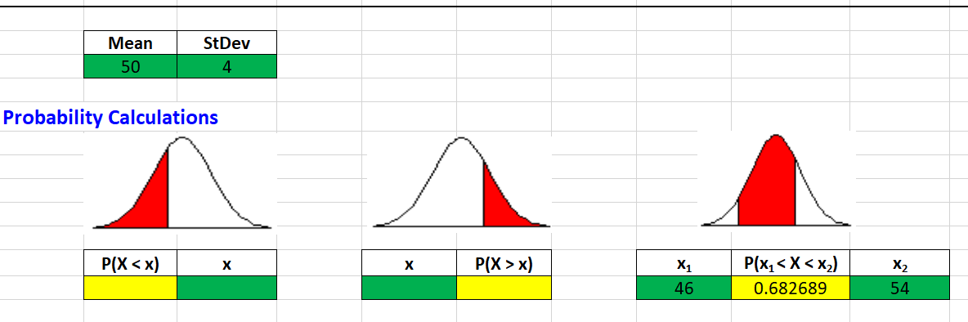

As shown in the yellow cell with “between” probabilities, there is a 68.3% chance of this outcome, consistent with the 68% in the Empirical Rule.

Using the Empirical Rule
Using this same distribution, the Empirical Rule can be used to estimate the percentage of values between 42 and 58. It can be seen that this range reflects two standard deviations from the mean.
50 – 4 – 4 = 42
50 + 4 + 4 = 58
Therefore, one would estimate that 95% of the data in the distribution would fall within this range.

If there were a total of 250 data points in this data set with a mean of 50 and standard deviation of 4, then it would be expected that 95% of those points would be between 42 and 58, or about 250*0.95 = 238 data points.

