MATH221, Week 4
Finding values within a normal distribution

Introduction
Sometimes a problem or situation gives a specific probability, seeking to determine the value from the distribution that cuts off that percentage. For example, imagine a group of runners that run the mile with an average time of 5.32 minutes and a standard deviation of 0.36 minutes. A shoe company decides to sponsor the top 10% of runners. In other words, they want to sponsor the 10% of runners with the shortest mile run times. These types of problems would let the shoe company and runners know how fast they need to run in order to be sponsored by the shoe company.

Problems going from a probability or percentage to a value in the original data set are considered inverse problems. The shoe company sponsoring runners is an example of an inverse problem. In contrast, the previous problems done in this chapter are going from a value in the original data set to a probability based on that value.

Which tail?
Sometimes, the hardest part of these questions is determining in which tail the percentage lies. In the example above, the “best” runners would be those with the shortest times. Therefore, the 10% best runners would be in the left tail of the distribution.

However, if the problem were asking for the top scoring football players, that would be those in the right tail. The “best” scoring players would be those with the most points.

Once the tail has been determined, then the values can be put into the week 4 spreadsheet. For the runners’ problem above, the values would be a mean of 5.32, a standard deviation of 0.36, and the 0.10 for 10% would be in the inversion portion with the left tail highlighted. These go in the green cells.

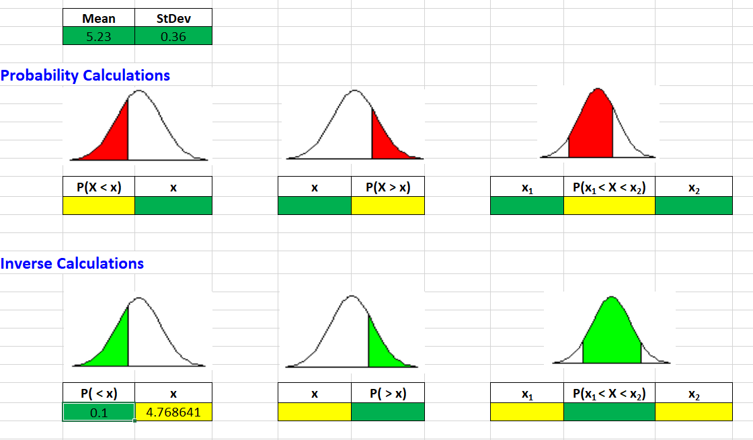

This result shows that the shoe company would sponsor any runner with a time of 4.7686 minutes or less.

