MATH221, Week 4
Central Limit Theorem

The central limit theorem focuses on the average of a sample instead of focusing on one specific value in the data set. One example would be if an average of 20 homes was selected and one wanted to know the probability of the average of the sample being above a set value.

Central Limit Theorem
Imagine that each student in this class asked 15 DeVry students for their age. Coming back to class, each student would provide the instructor with the average age of the 15 students that they asked. The instructor then has a data set that only has sample averages. The Central Limit Theorem only relates to the instructor’s data set. . . a data set of sample means.

The average of the instructor’s data set would be the same as the overall data set. If on average, the overall age of DeVry students was 30.4 years, then the instructor’s data set of sample means would be expected to also have a mean of 30.4 years. However, because the instructor’s data set is based on sample averages, this data set would not have the extreme values of the overall data set. If there was one DeVry student that was 81 years old, none of the averages based on a sample of 15 would work out to be 81 years. If that elderly student was included in one of the samples of 15, their age would be averaged with the others in the sample before being part of the instructor’s data set. Therefore, the instructor’s data set is less disperse and will have a smaller standard deviation. The standard deviation of the instructor’s data set would be equal to the standard deviation of the original data set divided by the square root of the sample size. In this example, the standard deviation would be divided by the square root of 15.

A problem uses the Central Limit Theorem when the phrase “of the sample” is included. A mean and standard deviation are needed to do the calculation within the week 4 spreadsheet. The mean would be the same as the original mean. The standard deviation must be adjusted by dividing it by the square root of the sample size.

Example
The average age of all DeVry students is assumed to be 30.4 years with a standard deviation of 1.8 years. If a group of 25 students was asked their age, what is the probability that the mean of the sample would be greater than 31 years? [emphasis added]

Going to the week 4 spreadsheet, the mean would be 30.4. To adjust the standard deviation, a calculator can be used, or use the lower part of the week 4 spreadsheet.
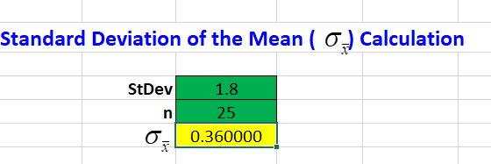

With an overall standard deviation of 1.8 and a sample size of 25, the adjusted standard deviation would be 0.36. Now the values can be put into the upper part of the week 4 spreadsheet.

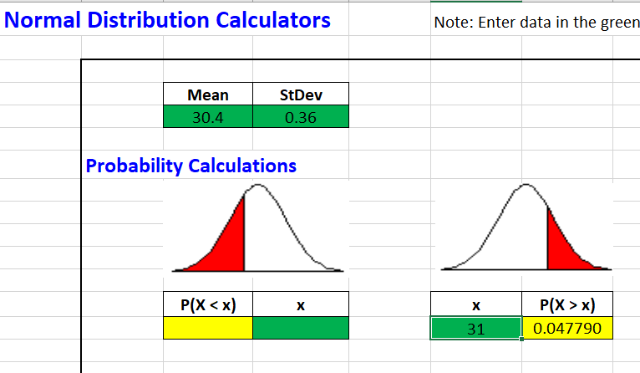

The probability that the mean of the sample would be greater than 31 years would be 0.04779 or about 4.779%. Since this is less than 5%, an outcome of more than 31 years would be considered an unusual event.

