**Objective:**

The objective of this exercise is to use video and video analysis software to measure the motion of carts on a track. The carts will collide in elastic and inelastic collisions. You will use the video analysis software to measure the momentum of the carts before and after the collisions to investigate the conservation of momentum and energy.

**Parts and Equipment Required:**

1. Computer with Internet and an iLAB link
2. *Tracker.jar* video analysis software
3. Five video files: *inelastic_equal_masses.mov, inelastic_blue500.mov, elastic_equal_masses.mov, elastic_red500.mov,* and *elastic_blue500.mov*

**Introduction:**

The momentum of an object is equal to the mass of the object times its velocity (). An impulse is needed to change the momentum of any object or system of objects. If there are no external forces acting on a system of particles then the total momentum of the system cannot change. In physics any quantity that stays unchanged is said to be conserved. A collision is when two or more particles interact. In an inelastic collision the particles stick together and move with a common final velocity. In a perfectly elastic collision the particles bounce off and move with different velocities but both the momentum and the total kinetic energy of the system are conserved. To keep the calculations simple, we will only consider one dimensional collisions in which one moving particle collides with a single stationary particle. In the case of an inelastic collision conservation of momentum yields:

$total {momentum}_{after collision}=total {momentum}_{before collision}$

$$\left(m_{1}+m_{2}\right)v_{f}=m_{1}v_{1i}+m_{2}v_{2i}$$

$$v_{2i}=0→ \left(m_{1}+m_{2}\right)v_{f}=m_{1}v_{1i}$$

$$v_{f}=\left(\frac{m_{1}}{m_{1}+m_{2}}\right)v_{1i}$$

For completely elastic collisions assuming that both the systems’ kinetic energy and the total momentum are conserved give the following equations for the final velocities of the two particles:

$$v_{1f}=\left(\frac{m_{1}-m_{2}}{m_{1}+m_{2}}\right)v_{1i}$$

$$v_{2f}=\left(\frac{{2m}_{1}}{m_{1}+m_{2}}\right)v_{1i}$$

Trying to measure a cart’s motion using distance sensors would be extremely difficult, but a video of the collision and the proper software will make the measurement easy. Any video (or movie for that matter) is a series of still photographs (frames) taken at precise time intervals. This time interval is called the frame rate of the video. If we could analyze a video frame by frame, we could build a motion diagram of the object. With a coordinate system and a scale, we can then measure the position of the object in every frame and use the changes from frame to frame to calculate velocities. ***Tracker*** (written by Douglas Brown of Cabrillo College) is software that will allow us to analyze a video file in this way. You will use Tracker to analyze five videos. The first two videos show the inelastic collision of two carts on a track. You will measure the average velocity of the moving cart before and after the collision, calculate the total momentum before and after the collision and compare the momenta to see if they are the same. The last three videos show the elastic collision of the two carts. You will analyze these videos and compare the final velocities of the two carts with values calculated by assuming that the collisions are completely elastic.

**Procedure:**

1. **Setup**

**Option 1**

* 1. Login into iLab at [www.lab.devry.edu](http://www.lab.devry.edu)
  2. Download the video files: *inelastic_equal_masses.mov, inelastic_blue500.mov, elastic_equal_masses.mov, elastic_red500.mov,* and *elastic_blue500.mov* to a folder on your computer.
  3. Use Windows Explorer to copy the files *inelastic_equal_masses.mov, inelastic_blue500.mov, elastic_equal_masses.mov, elastic_red500.mov,* and *elastic_blue500.mov* to the *F:* drive.
     1. Open Windows Explorer from the list of Apps
     2. Click on *Local Disk* and find the video files
     3. Highlight the video files, right click and copy (or ctrl-C)
     4. Click on *Computer* on the left side of the screen and then the F drive (F:)
     5. Open the Desktop file and paste the video file (ctrl-V)
  4. Close Explorer and open *Tracker* by clicking on the *Tracker* icon under Apps
  5. When Tracker opens explore the software and read the help file.

**Option 2 (recommended)**

* 1. Alternatively, you can download the tracker software and access the files directly from your local computer: <http://physlets.org/tracker/>
  2. Click the appropriate button near the top of the screen and the download will start automatically.

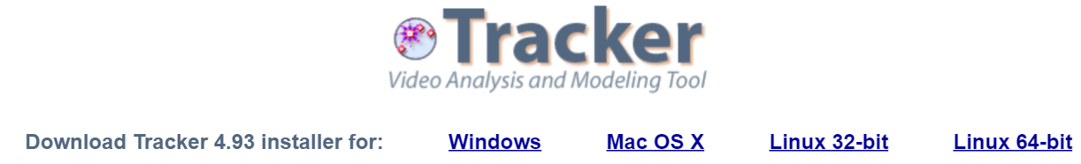

1. **Video 1 Inelastic collision with equal masses**
   1. Use the open file tool button() to open *inelastic_equal_masses.mov,*  from the F: drive or your computer
   2. Play the video and then step through the video one frame at a time.
   3. At the first frame, display the tape measure by clicking the tape measure button(). Place the tape measure by dragging the ends to the edges of the aluminum track.. The tape measure initially reads number of pixels. Change the scale by double-clicking on the number and typing 2.30.
   4. 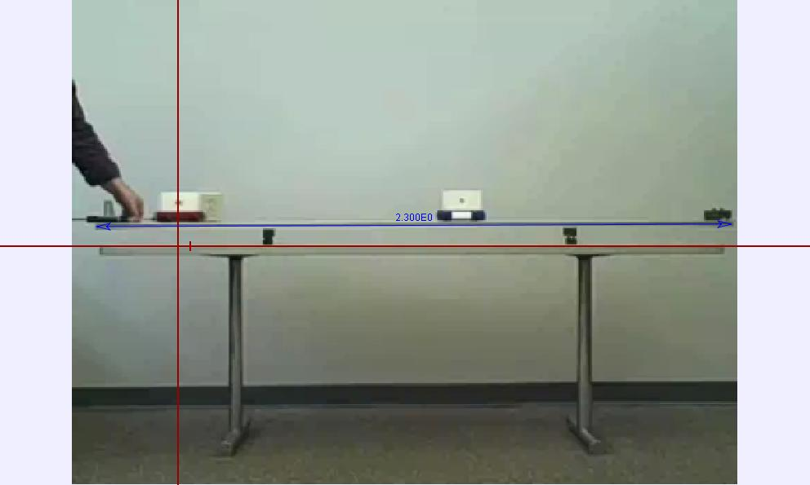Display the axes by clicking the Axes button ( ). Drag the axes so that they align with the table and the starting position of the cart as shown in **Figure 1**. Take care that the x-axis is parallel with the track. At this point your Tracker window should look like Open the tracker control. Create a new point mass marker. Click on the name item on the drop down menu and rename the point mass red cart. Advance the video frame by frame until you reach the frame where the red cart passes the first track support.. Carefully mark the position of the cart by holding the shift button while clicking the mouse. You may zoom in to get a more accurate position. The video should automatically advance to the next frame. Mark the next position of the cart. Repeat until you have marked the cart in every frame until the red cart reaches the second support. reaches the floor. The video should look like **Figure 2**. Play the video and notice that the tracks highlight in turn as the cart(s) move.

Figure 1 Single frame of a momentum video showing the scale and the axes

* 1. Save your work to the F: drive or your computer as *inelastic_equal_masses.trk*.
  2. Pull open the graph and double-click on the graph of Vx versus time. Use the statistics feature of the data tool to find the average velocity of the red cart before and after the collision.
  3. Paste a copy of your velocity data in the space provided on the data sheet.
  4. Record the initial and final velocities and momenta in the table provided on the data sheet. Both the red and the blue carts have masses of 0.255 kg in this experiment.

1. **Video 2 Inelastic Collision with Unequal Masses**
   1. Repeat the above procedure with the video *inelastic_blue500.mov.*
   2. The blue cart has a mass of 0.755 kg and the red cart has a mass of 0.255 kg in this video.
2. **Video 3 Elastic Collision with Equal Masses**
   1. Open the file *elastic_equal_masses.mov* from the tracker file menu.
   2. 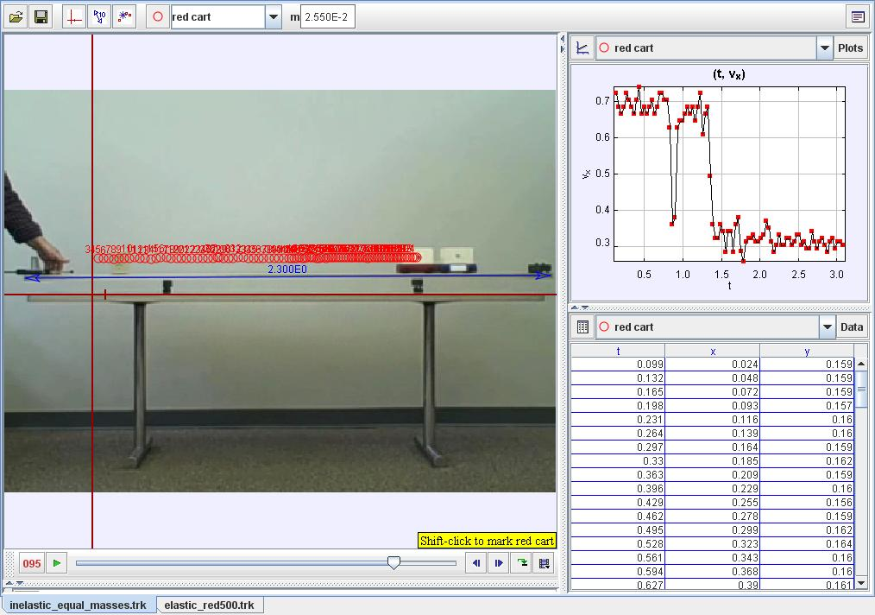Set the scale marker and the axes just as you did in the previous cases.

Figure 2 Screen capture of Tracker window showing video, graph and data table

* 1. Create a point mass marker and mark the center of the red cart for each frame from the frame that the red cart passes the left support until at least ten frames after the collision.
  2. Create a second point mass marker named blue cart and mark the position of the blue cart from at least ten frames before the collision until the blue cart reaches the right track support.
  3. Use the statistics feature of the data tool to find the average velocity of the red cart before and after the collision. Click on the blue cart tab to find the average velocity of the blue cart after the collision.
  4. Paste a copy of your velocity data in the space provided on the data sheet.
  5. Record the initial and final velocities in the table provided on the data sheet.
  6. Use the given formulae to calculate the final velocities of both carts. Record the calculated values in the table. Calculate a percent difference between the measured and calculated values of the final velocities for both carts. Both the red and the blue carts have masses of 0.255 kg in this experiment.

1. **Video 4 Elastic Collision Moving Cart with Greater Mass**
   1. Repeat the above procedure with the video *elastic_red500.mov.*
   2. The blue cart has a mass of 0.255 kg and the red cart has a mass of 0.755 kg in this video.
2. **Video 5 Elastic Collision Stationary Cart with Greater Mass**
   1. Repeat the above procedure with the video *elastic_blue500.mov.*
   2. The blue cart has a mass of 0.755 kg and the red cart has a mass of 0.255 kg in this video.

**Completion**

Answer all questions and turn in your completed data sheet to your instructor.