Week 3 Stress Management Assignment
A statement you might be able to include in your mental outlook is “I am a master of my stressors.” The assignment due this week will involve assessing your current stress management approach.
Like earlier assignments, you will access SuccessU which will take you to the modules on various topics.
The module relevant this week is the “Stress Management” module.
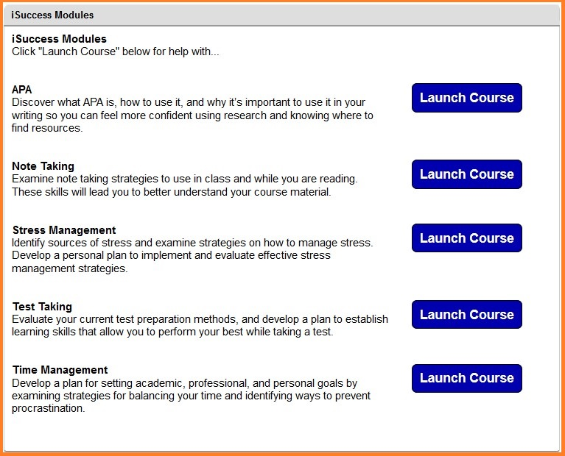
Your completed assignment is a reflection paper. In your write-up for this assignment, be clear in your discussion of how you currently manage your stress. Discuss two of the stressors you currently experience in detail. Finally, discuss two practical and realistic techniques that you can employ that will effectively target the specific stressors. Discuss the techniques thoroughly.
Be deliberate in the way you intend to manage your stressors. This assignment is a reflection of your mental outlook, so use it as a way to reveal the control you have in producing positive outcomes in your life.
Write your reflection in a Microsoft Word Document. Then, submit it. Please refer to the grading rubric below to understand how this assignment will be graded.

Grading Rubric
Graded Item | Description | Good/Fair/Poor/Incomplete
Reflecting on Stress Management Behaviors | Completed assignment is a well-developed self-reflection; It includes a discussion of the current approach taken to manage stress; The completed assignment includes a brief discussion of two stressors currently experienced; Finally, two techniques for managing stress are discussed thoroughly; It is clear how the strategies can be implemented; It is insightful and demonstrates critical thinking; It is approximately 2-3 paragraphs. | 40/30/10/0
Writing, Mechanics, & Grammar | Paragraphs are focused and flow from idea to idea. The completed assignment is not a collection of random thoughts.  Writing is clear. Student has elaborated on the insights gained and used examples to provide further clarity.  Writing is correct. Any errors in spelling, punctuation, and grammar do not interfere with meaning. | 10/5/2/0
Total Points Earned
Total Points Possible |  | 50

