Week 5 Informational Interview Assignment
The purpose of this assignment is for you to become familiar with your degree program, your future occupation, and the extent to which these align with one another.

This document will help you navigate to the specific sites you will need to visit in order to complete this assignment. The final page of this document contains the items you will provide responses to in order to complete this assignment separated into sections labeled 1, 2, and 3.

Upload your responses as a Microsoft Word document by the assignment deadline.

Grading Rubric
Graded Item | Description | Good/Fair/Poor/Incomplete
Section 1 | A brief, yet thorough description of what the degree program you are pursuing is all about written in your own words | 10/5/2/0
 | A brief, yet thorough description of what the specialization you are concentrating in is all about written in your own words | 10/5/2/0
 | Direct link to program guide used | 10 all or nothing
Section 2 | A brief, yet thorough description in your own words what individuals do within this profession with mention of two or three duties | 10/5/2/0
 | A brief discussion, in your own view, on the extent to which the competencies you will develop in pursuing your degree and specialization align with what professionals in the occupation actually do | 15/10/2/0
 | Direct link to OOH web page used | 10 all or nothing
Section 3 | At least five questions you would ask an individual in your career of interest during an informational interview to elicit invaluable information about the occupation | 15/10/2/0
 | A brief explanation to reveal why you have chosen each question | 10/5/2/0
Writing and Formatting | Writing is clear. Writing is grammatically and mechanically correct.  Responses are well-formatted and the completed assignment is easy to follow from one section to the next. | 10/5/2/0
Total Points Earned
Total Points Possible |  | 100
Step 1: Navigate the Web to Retrieve Your Degree Program Guide

- Go to http://www.devry.edu/degree-programs/program-guides.html

- Download a DeVry Program Guide by selecting the hyperlink that best describes your specialization. It will look like this.
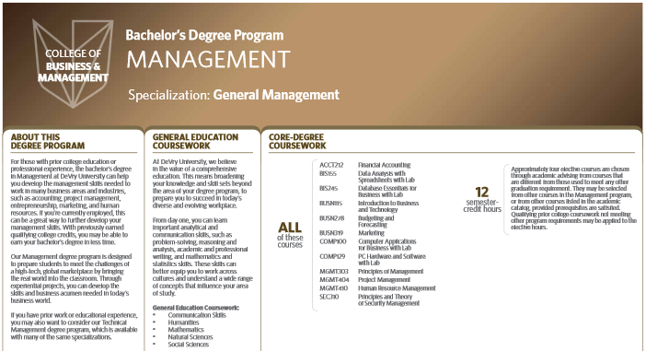
- Read the two-page DeVry Program Guide.

- Then, respond to the items in Section 1.

Step 2: Navigate the Web to Research Your Career of Interest

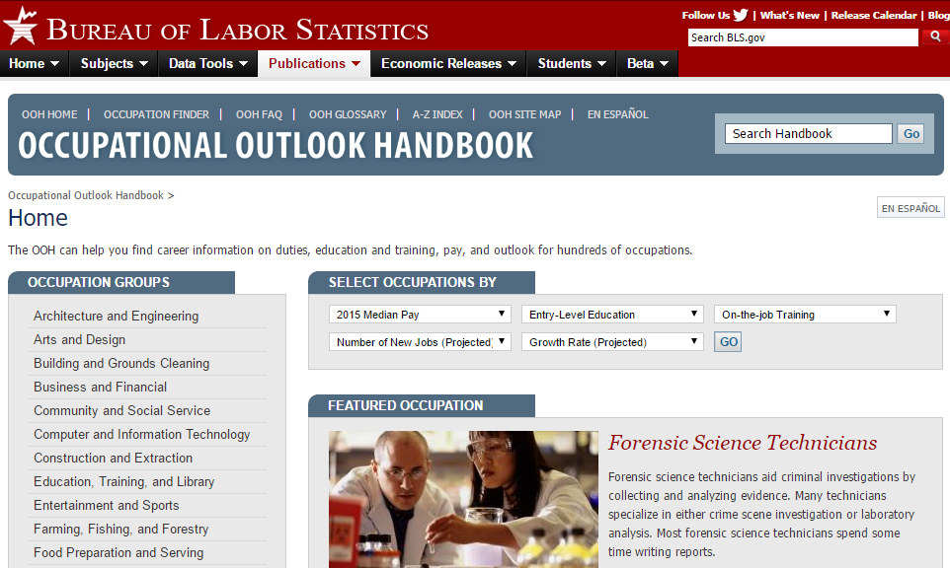
- Go to http://www.bls.gov/ooh to learn more about an occupation in your field of interest.

  - Select one of the categories under Occupation Groups in the list on the left.

  - Search for one of the career titles you have made a note of. (If you cannot find your career title on this page, enter it in the upper right search box.)

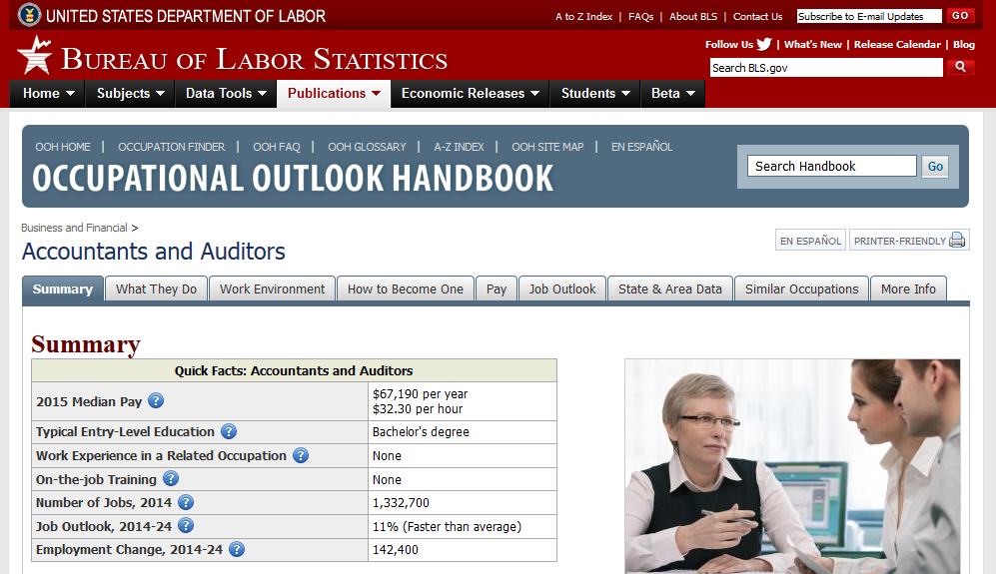
- At the top of the career listing, you will see tabs for various categories. Click each of the tabs, and study the content for one career of interest.

- Then, provide responses to the items within Section 2.

Step 3: Respond to the Items within Each Section

Instructions: Copy and paste the items below into a separate Microsoft Word document. Write your responses to each item into paragraphs. Format your responses so that they are easy to recognize. Insert page breaks between each section in your completed assignment.

Section 1: About your Degree Program and Specialization
After reviewing the DeVry Program Guide, briefly describe what your degree program is about in your own words (1–2 paragraphs).
After reviewing the Program Guide, in particular the Specialization, briefly describe in your own words what expertise you will develop in pursuing this specialization (1–2 paragraphs).
Include the direct link to the Program Guide by copying the address from the address bar of your web browser and pasting it here.
Section 2: About Your Career of Interest

After reviewing the Occupational Outlook Handbook on the Bureau of Labor Statistics website, briefly describe in your own words what individuals do within this profession. Include two or three duties in your description of what these individuals do, and elaborate on each in your own words (1–2 paragraphs).
Given what you learned about your Degree Program, Specialization, and your occupation from the Bureau of Labor Statistics website, in your view, how will your degree program prepare you for the occupation? In other words, to what extent are the competencies you will develop in pursuing your degree and specialization aligned with what professionals in the occupation actually do (2–3 paragraphs)?
Include the direct link to the specific Occupational Outlook Handbook web page, which you referenced in developing the content for your response above by copying the address from the address bar of your web browser and pasting it here.
Section 3: Questions for an Invaluable Informational Interview
Given what you know about the degree and specialization you are pursuing, and what professionals within this field actually do, list at least five questions you would ask an individual in your career of interest during an informational interview to elicit invaluable information about the occupation. Following each question, provide a reason why you have chosen the question.

