## Objective: The purpose of this exercise is to measure the buoyant force on and the volume of water displaced by a submerged hanging mass. By varying the volume of the mass you will verify Archimedes’ Principle.

**Parts and Equipment Required**:

* Computer with PASCO Capstone software installed
* Capstone experiment file: *PHYS310_W7_lab7B.cap*

**Introduction:**

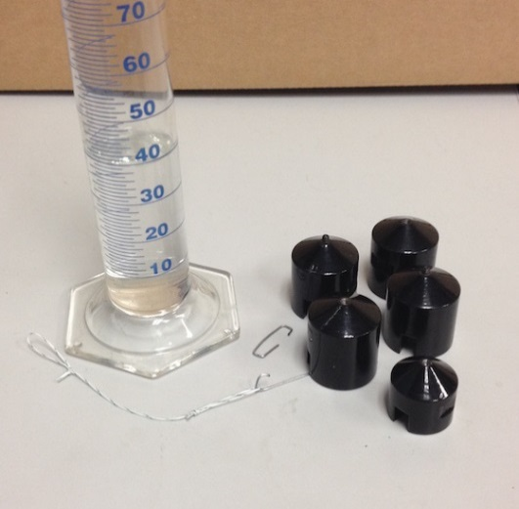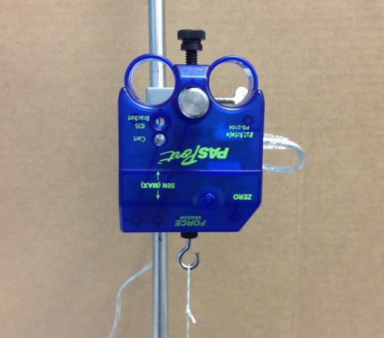

An object that is submerged in a fluid will displace its own volume of the fluid. Archimedes’ principle states that the displaced volume of fluid exerts a buoyant force on the object that is equal to the weight of the displaced fluid. In this experiment a hanging mass (see the figures) is suspended from a force sensor by a string. The apparent weight of the mass is measured before and after it is completely submerged in a glass graduated cylinder that has been filled with approximately 40 mL of water. The displaced volume is measured by comparing the water levels before and after the hanging mass is submerged. The buoyant force is measured by the difference in the apparent weigh of the mass before and after it is submerged. The measurement is repeated for total masses ranging from 0.400 kg to 0.100 kg. A graph of the buoyant force versus the  
displaced volume can be fit to a straight line. The slope of the straight line should be equal to the density of water times the acceleration due to gravity. 

This exercise is different from the other labs in this course. The experiment has been done for you. You will analyze the data.

**Procedure:**

Start Capstone and open the Capstone file: *PHYS310_W7_lab7B.cap.* The open file should look similar to the figure below. In the file are pre-recorded runs of force data and before and after photos of the water level in the graduated cylinder for each data run.

Read the volumes in mL from the photos and calculate the displaced volume by subtracting the volume in the before photo from the volume shown in the after photo. Convert the volume from mL to m3 and record it on your data sheet. Repeat for each of the seven measurements.

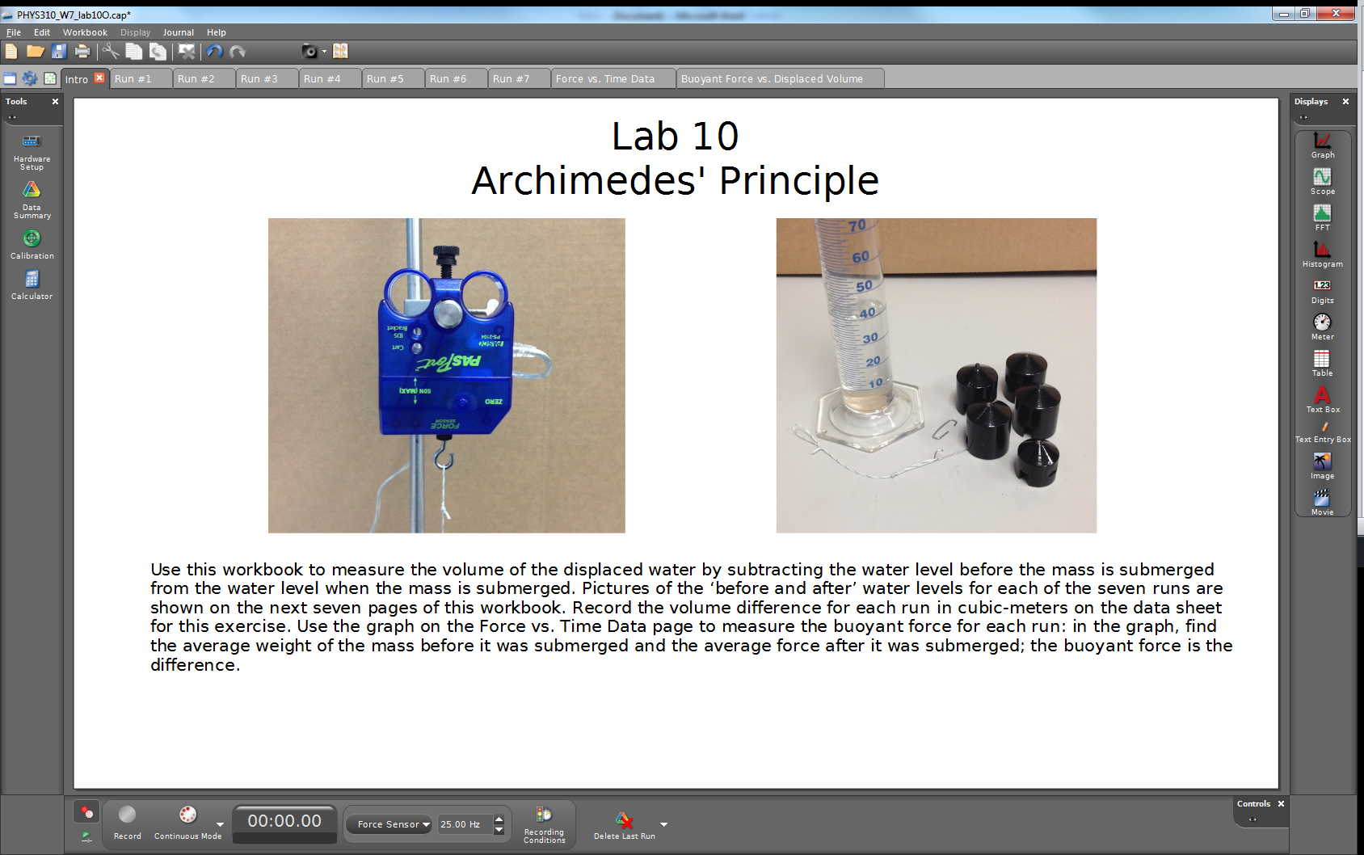

In the graph on the *Force vs. Time Data* page, there are seven measurements of the apparent weight of the hanging mass. Measure the weight of the mass by selecting the data before the mass was submerged and using the statistics tool to measure the average.

1. Select a run by left clicking on it

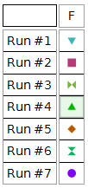

1. Use the highlight range  to select a portion of the data before submersion. Resize the box as necessary.
2. Click the statistics button to show the mean value and record. Repeat for the portion after submersion and repeat for the other runs

Find the buoyant force by subtracting the before and after submersion measurements for each run. Record the buoyant force in the table on your data sheet. Select the last page of the workbook and record your data in the provided table. Do a straight line fit on the resulting graph and record the slope on your data sheet. Use the measured slope to calculate the density of the fluid and compare this with the standard value of the density of water by calculating a percent difference. Complete the data sheet and turn it in.