PROJ430 Project Exercise 6: Setting Baselines, Performance Monitoring, and Corrective Action Plans

Overview
In this exercise, you will save the project plan as a baseline. You will also update the project’s status as of August 5, 2015. You will enter actual start and finish dates for the Overhaul Machine 1 and Overhaul Machine 2 tasks, which have been completed. You will also enter information for Test Machine 1 and Test Machine 2 tasks that have started, but have not yet completed. Many of the tasks started late, or took longer to complete than originally estimated, so you will shorten one of the critical tasks (Test Machine 2) to finish the project as close to the original, August 10th target date as possible. Finally, you will analyze a Schedule Variance report so you can see the activities that led to the need for a corrective action plan.
How To Do It
- Get the MS Project Exercise 5 Finish Exercise 6 Starter File.mpp and open it up – it looks like this.
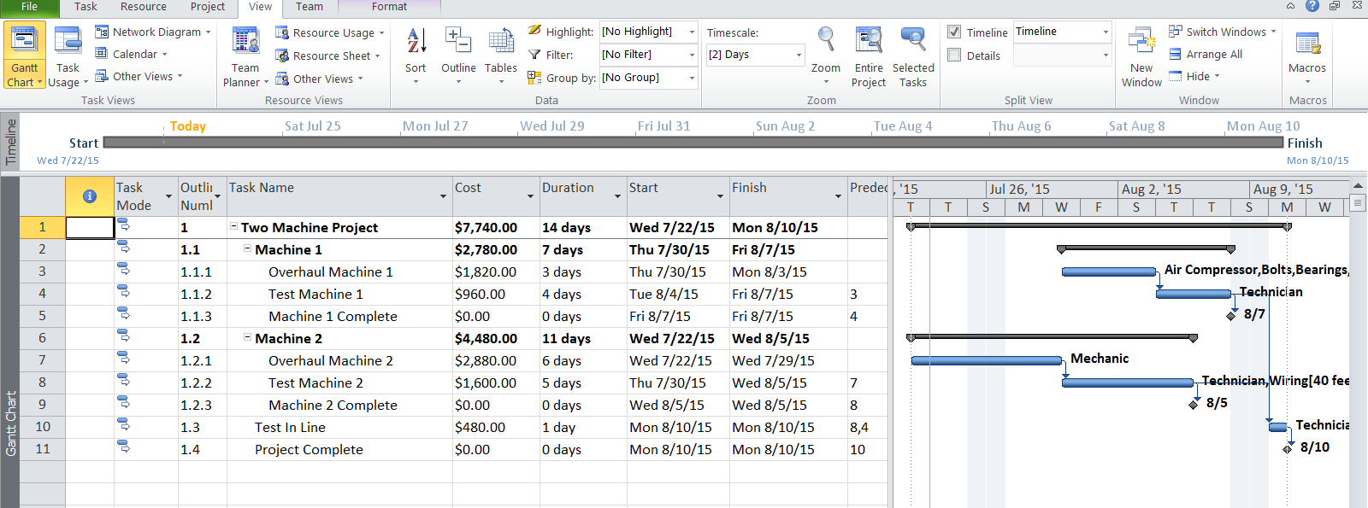
- This represents your project plan with a total cost of $7,740 and a project finish date of August 10, 2015, composed of 14 working days. Memorize this plan by setting a baseline. This baseline will represent your budgeted/planned values against which you can assess actual performance and make corrective action plans. Set the baseline by going to Project – Set Baseline. Nothing appears to happen, but MS Project will memorize your project and use these original values in subsequent reports and tables.
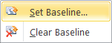
- Now it’s time to update the project with actual progress. Assume the project status date is Friday August 5, 2015. Set the project status date by going to Project – Project Information and updating the Status date column. Also set the current date to August 5th to simulate moving ahead in time since our planning. Press OK when done.
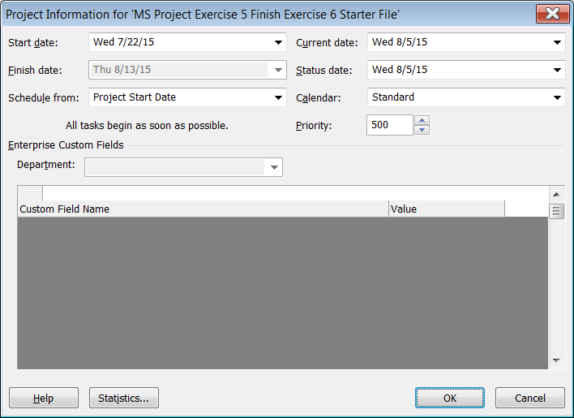
- Assume you received status reports from team members regarding the progress made on tasks to which they were assigned. One way to get a status report is to ask team members for when they started their assigned task, and when they finished it. If the task is not finished, get the date they started and the time remaining to complete the project.
- Enter this data in MS Project by selecting the Overhaul Machine 1 task in Table-Entry view. Go to Task-Mark on Track – Update Tasks, and enter the data for the Overhaul Machine 1 Task.
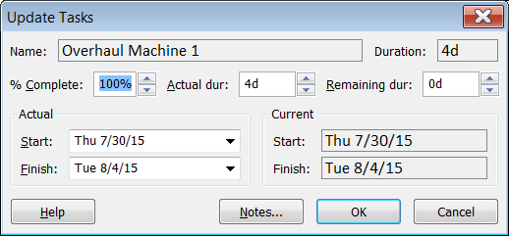
- Press Ok and select the Gantt Chart View again to see how the project changed. It updated the schedule with the new information. Now, select Test Machine 1, and go to Task-Mark on Track-Update Tasks. Enter the actual data for Test Machine 1, which is started, but not finished, and needs 5 more days to complete.
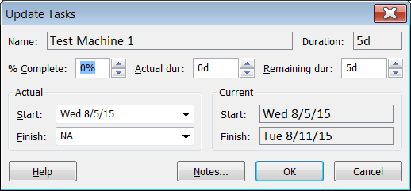
- Select the Overhaul Machine 2 task and update its progress with the actuals.
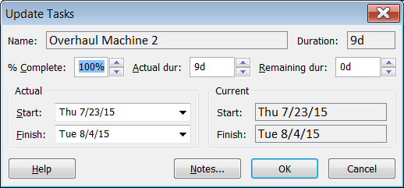
- Do the same for the Test Machine 2 task.
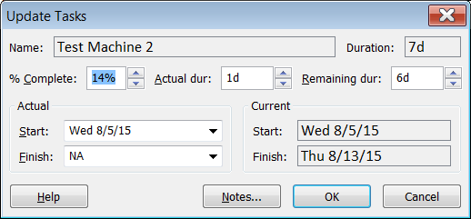
The Test In Line task has not yet started, so we don’t update it. If the team was able to get started on it early, we could update its progress, but in this case, they have not started on it because predecessor tasks have not yet completed.
- Go Back to Gantt Chart view. Notice how tasks with progress have black progress lines indicating how much of the task is complete. Notice how the project finish date has extended from August 10th to August 13th due to tasks starting late or taking longer than planned.
- Assume that missing the planned finish date of August 10th, 2015is unacceptable. Therefore, we need to shorten the critical path by three days, if possible, to achieve this date. Display the critical path by going to Format and checking Critical tasks.
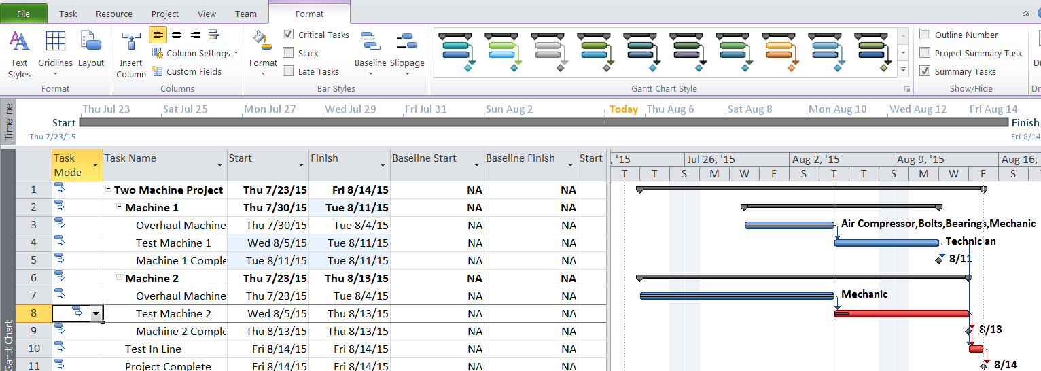
- We need to shave off three days from Testing Machine 2 or Testing in line. Testing in line is only one day long, so that will be difficult to shorten. Therefore, we must try to shorten Testing Machine 2 by as much as we can to hit the August 10th planned finish date. Assume you checked with the project team and the most they can shorten test Machine 2 is to 5 days. Therefore, shorten the duration value for Test Machine 2 to 5 days.
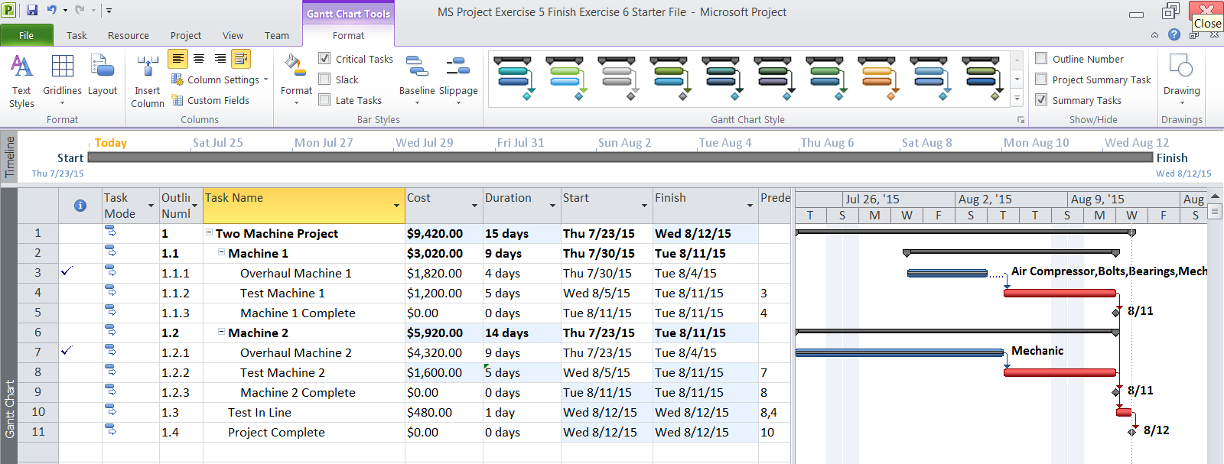
- Look at the new schedule. Shortening the Test Machine 2 task to 5 days moved the expected project finish date to August 12th – the best you can do given delays on the project. It has also made Test Machine 1 a critical activity that must be watched closely. Shortening Test Machine 2 is considered your corrective action plan.
- Go to View – Table - Variance. You can see where the various delays occurred by looking at start and finish date variances. The Start and Finish columns are Actual columns. The Baseline start and finish columns are from your original project plan, which you saved when you set the baseline.
Overhaul Machine 1 started a day late and will finish 2 days late as evidenced by its start and finish variances. You can determine how this happened by looking at individual task start and finish variances.
Test Machine 1 started a day late as a result, and added another day of lateness to its finish date. Overhaul Machine 2 started a day late, and finished four days late, which cascaded to Testing Machine 2. We have not yet started in Testing in Line, but when it is complete, the project will have missed its finish date by 2 days – the best we can do given delays in the project.

