PROJ430 Project Exercise 7: Reports in MS Project

Overview
In this exercise, you will look at various reports you can create in MS Project 2010. These include cash flow reports (also called Time Phased Budgets), Budget Reports, Earned Value Reports and Schedule Variance reports. You will use different files from previous exercises, and you will learn to edit reports for sorting and personal preferences.
How To Do It
- Open up the Project Exercise 4 Finish Exercise 5 Starter File.mpp file. It looks like this.
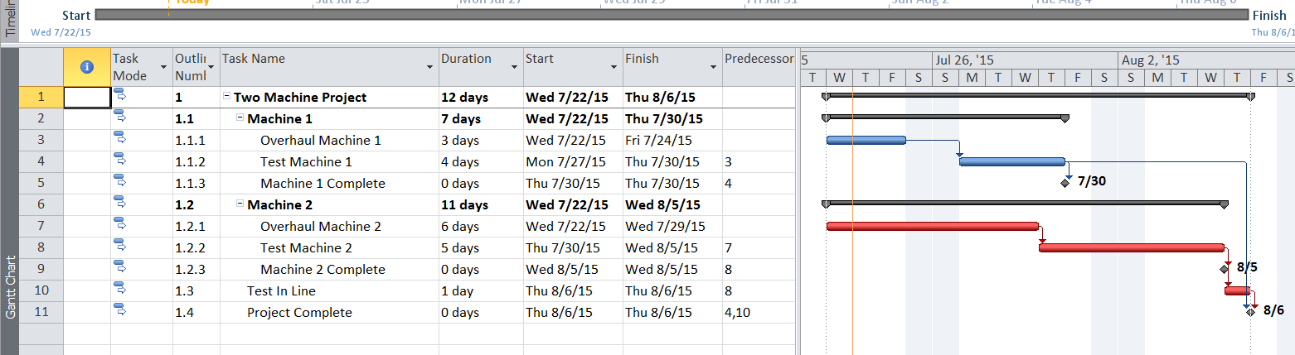
- Go to Project – Reports – Costs and Cash Flow Report. This report will show you the time-phased budget for the project at the planning stage. This report is useful for planning your cash needs over the life of the project. It shows each activity, its budget, and when you will need to fund the budget.
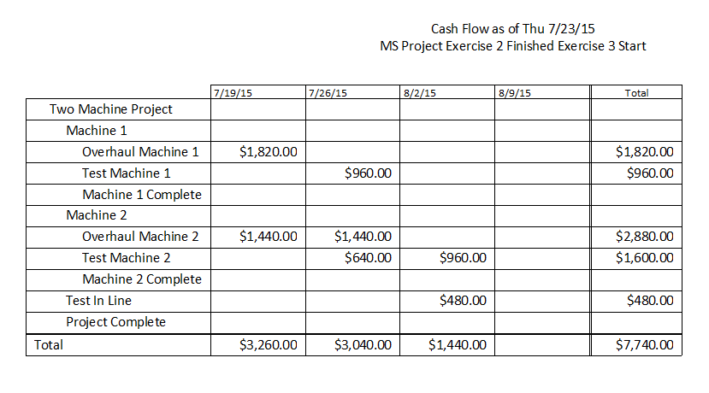

- Open up the Project Exercise 6 Finish.mpp file. Go to Project – Reports – Costs – Budget. This report will show you your budget, actual, and variance figures at the current update of the project schedule.

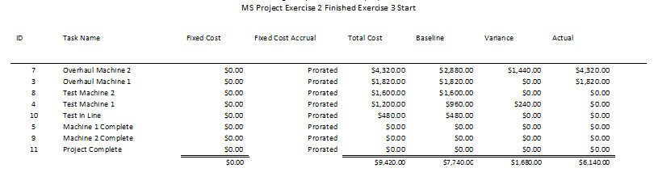
- The next report is an Earned Value Report (stay with the MS Project file you have open). An explanation of Earned Value is beyond the scope of this exercise. However, there are good explanations in textbooks and online. A key column in this report is the CV (Cost Variance) column. This column indicates how much over, or under the Earned Value of each activity you have achieved. Earned value is simply the total budget of an activity (its Planned Value) multiplied by its percent complete. This earned value is the amount you should have spent (theoretically) given how much of the activity you have currently completed. The CV (cost variance) is the amount you are over, or under the earned value based on your actual costs.
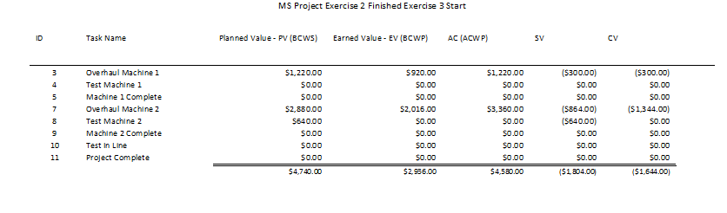
- You can sort and customize the data in these reports before you run them. For example, if you want to sort your budget report alphabetically, go to Project-Reports-Cost and select the Budget report in the MS Project file you have open.
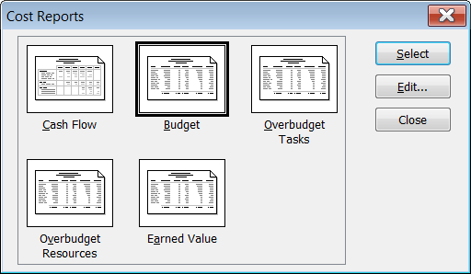

- Select the Edit button, and then the Sort button, and the sort by Start (task start date) in ascending order.
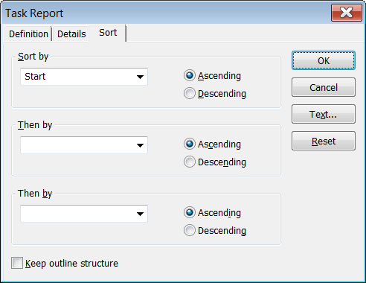

- Press the OK button and then the Select button on the next screen to get your budget report sorted by the date when each task starts.
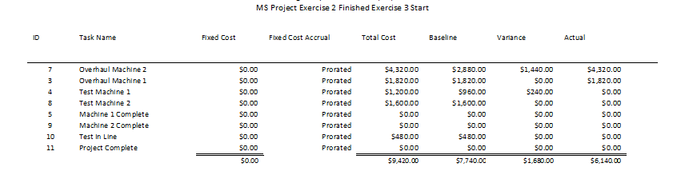
- You can also create reports from the View-Tables option. Take a screen shot of a table of interest, such as the Schedule Variance report found in View-Table-Variance option.
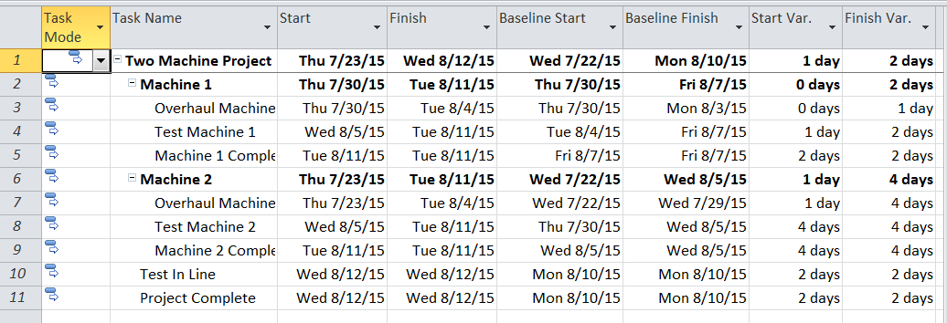
Note: For formal reports that require APA style, you should place screen shots of reports in an APA formatted table with an appropriate title etcetera. Scroll to the next section to see how you format a screen shot for APA style. Pay attention to bold face type in italics.

Figure 1.0. Two-Machine Project Schedule

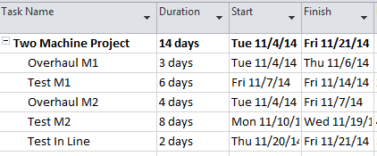

Figure 1.0. Two-Machine Maintenance Project Schedule in Microsoft Project. Start and finish dates represent the earliest each task can begin or end.

