MATH221, Week 4
Standard Scores and the Empirical Rule

Standard Scores
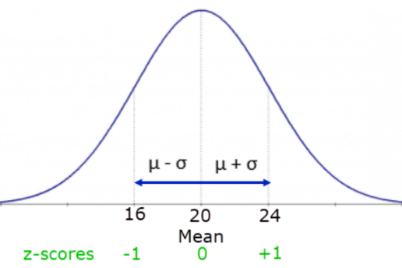
A standard score, also called a z-score, is a way of converting data points to a more standardized measure. The standard score represents the distance between a given measurement x and the mean, expressed in standard deviations. For example, if a data set had a mean of 20 and a standard deviation of 4, consider the standard score of one specific data value of 24. Twenty-four is 4 units up from the mean. Since the standard deviation is 4, then the data point of 24 is exactly 1 standard deviation higher than the mean. The value of 24 would have a standard score of 1. In the same data set, another specific data point might be 16. The value of 16 is one standard deviation lower than the mean, so would have a standard score of -1. Data values with negative standard scores are values that are less than the mean. Data values with positive standard scores are values that are more than the mean.

Note: The week 1 spreadsheet can calculate the standard score, or z-score, for any data value.

Empirical Rule
The Empirical Rule only applies to data sets that have a symmetrical, mound-shaped distribution. This type of distribution is also called a normal distribution. The Empirical Rule has three parts:

* Approximately 68% of the data values will fall within 1 standard deviation of the mean.
* Approximately 95% of the data values will fall within 2 standard deviations of the mean.
* Approximately 99.7% of the data values will fall within 3 standard deviations of the mean.

Consider a normally distributed data set with a mean of 30 and standard deviation of 1.2. Using the Empirical Rule, the following can be estimated:

* 68% of the data values in this data set are between 28.8 and 31.2. These values are found by subtracting and adding the standard deviation once to the mean:
30 – 1.2 = 28.8
30 + 1.2 = 31.2

* 95% of the data values in this data set are between 27.6 and 32.4. These values are found by subtracting and adding the standard deviation twice to the mean:
30 – 1.2 – 1.2 = 27.6
30 + 1.2 + 1.2 = 32.4

* 99.7% of the data values in this data set are between 26.4 and 33.6. These values are found by subtracting and adding the standard deviation three times to the mean:
30 – 1.2 – 1.2 – 1.2 = 26.4
30 + 1.2 + 1.2 + 1.2 = 33.6

Alternatively, if the problem gives the mean, standard deviation, and a range, then the Empirical Rule can help determine the percentage of data that would fall in that range. For example, if the mean of the data set is 30 and the standard deviation is 1.2, what percentage of the data values would be estimated to fall in the range of 27.6 and 32.4? Consider how many times the standard deviation needs to be subtracted and added to the mean to arrive at that range.
30 – 1.2 – 1.2 = 27.6
30 + 1.2 + 1.2 = 32.4
Since the standard deviation was subtracted and added twice, it would estimated that 95% of the data values fall in that range, based on the Empirical Rule.

