**When Do You Use Each Type of Graph?**

**Circle Graph/Pie Chart**

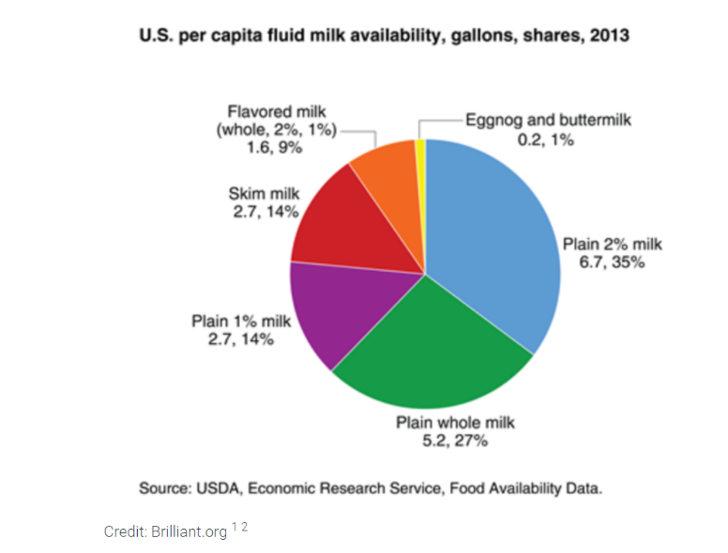Use a circle graph/pie chart when you want to know how a population or data set breaks down by percentage. In the graph above, one can quickly see that Plain 2% milk has the highest percentage of availability while Eggnog and buttermilk has the least availability. It is important to note that the circle graph/pie chart works best when the number of outcomes involved is relatively small. For example, if one tried to make a circle graph showing the percentage of the population living in each state, we would have a circle graph with 50 slices, most of which would be very tiny making the graph hard to read. The data set can be either quantitative or qualitative.

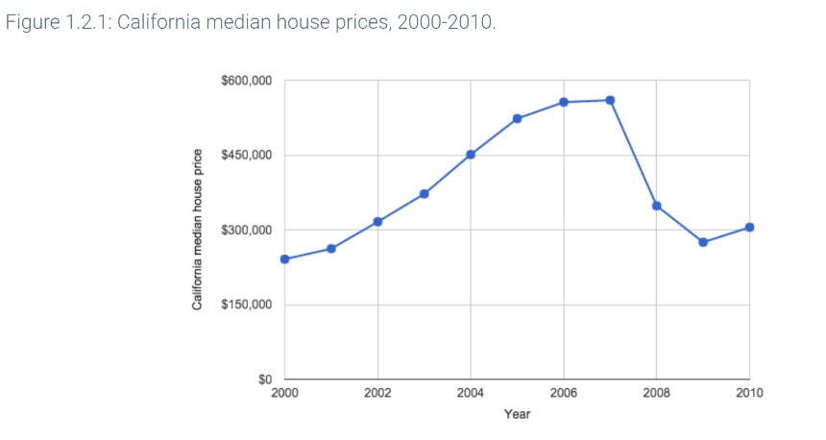**Line Graph/Time Plot**

Use a line graph/Time Plot when you want to examine trends or changes in behavior usually over a span of time. For example, in the graph above, one can quickly see that that median house prices in California were increasing steadily between 2000 and 2007 and then sharply declined between 2007 and 2009 before beginning to rise again after 2009. The data set should be quantitative.

**Bar Graph**

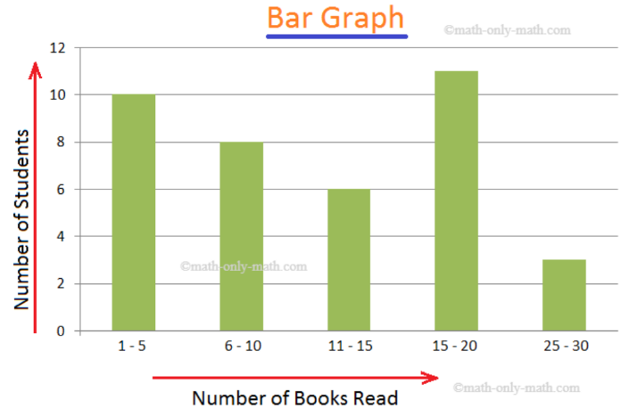Use a bar graph when you want to see the number of members of a population or dataset that belong in certain categories. Simple bar graphs are best used when the data has a natural order to it such as age groups or salary ranges. In the graph above, one can see that the most students read between 15-20 books. The ranges of books read increase as the graph moves from left to right. The data set can be either quantitative or qualitative.

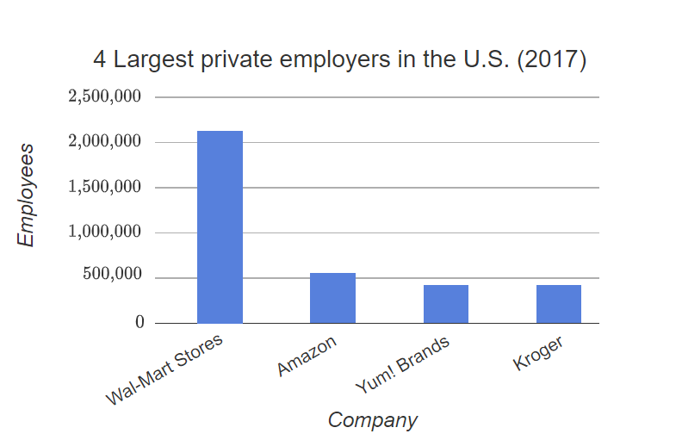**Pareto Chart**

A Pareto Chart is a form of bar graph where the height of the bars is sorted from tallest to smallest with the heights decreasing from left to right. Use a Pareto chart when the population or data set is categorical, qualitative, and has no built-in order. In the graph above, there is no built-in way to order these companies. The Pareto chart imposes order by showing the companies in order from most employees to least employees. One can quickly see that Wal-Mart employs the most people while Kroger employs the least.

**Histogram**

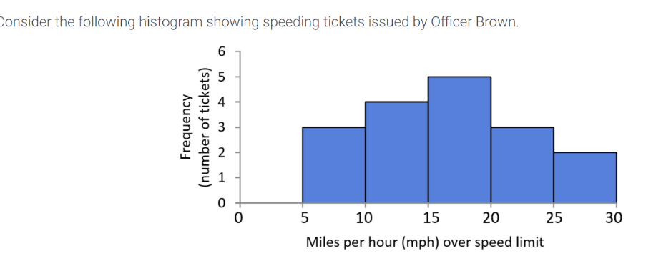Use a histogram when you want to examine the dispersion of the population or data set. The data set must be numerical or quantitative. The shape of the graph gives one important information about the data set or population. In the graph above, the shape is nearly symmetrical with the tallest bar in the middle. We can quickly see that officer Brown issued more tickets when drivers were 15 to 20 miles over the speed limit than any other.

**Scatter Plot**

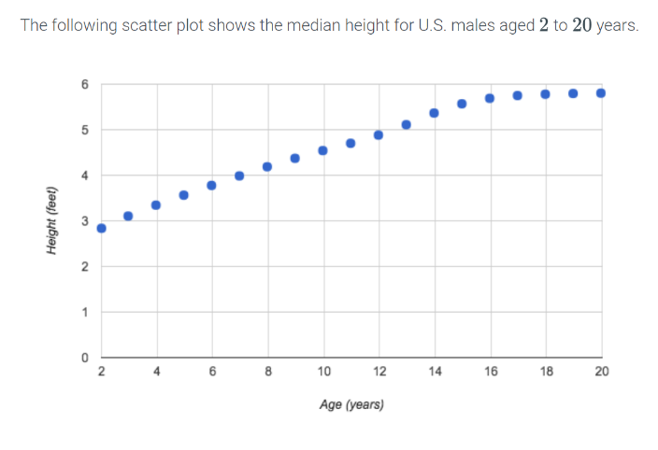Use a scatter plot when you want to see the relationship between two variables. This graph quickly lets one see the type and strength of a relationship between two variables. In the graph above, one can quickly see that the relationship between age and height for U.S. males aged 2 to 20 years is linear and strong as the pattern of dots follows very closely to a straight line increasing from left to right. The data must be numerical or quantitative for both variables involved.

**Stem and Leaf Plot**

Use a stem and leaf plot when you want to quickly see where gaps exist in the data and which values in the data set occur most frequently. You can also see overall trends in the data in this graph. The data must be numerical or quantitative. In the graph above, one can quickly see that there were no customers below the age of 15 or between 48 and 60 years of age. One can also see that there were more customers in the ages of 31 and 60 than any other age. Finally, one can see that most of the customers were between 20 and 50 years of age.

**Frequency Polygon**

Use a frequency polygon when you want to see the overall shape of a histogram without the bars present or when you want to compare the shapes of several histograms on the same graph. The data must be numeric or quantitative. In the graph above we can quickly see that while the general shapes of the distributions of the three diseases is mostly the same that disease y had the highest peak number of cases and that disease z peaked later than diseases x and y.

**Dot Plot**

Use a dot plot when you want a quick visual reference for a simple count of how many data values fall into given categories. Each dot above a category represents one data value that falls into that category. Data can be either categorical/qualitative or numeric/quantitative. In the graph above, we can quickly see that the most ordered pizza was pepperoni at 7 and the least was mushroom at 1.