Probabilities from Normal Distributions

Normal Distributions
Normal distributions are bell-shaped and symmetrical. If the mean of the distribution and the standard deviation are known, then the position and shape of the distribution is known. From there, probabilities can be determined for less than a value, greater than a value, or between two values.

Probability of less than a value
In the week 4 spreadsheet, the mean and standard deviation are typed in at the top. Then the top set of distributions calculate the probabilities of less than x, greater than x, or between two values of x.

If a normal distribution had a mean of 20 and a standard deviation of 1.8, then we could find the probability of a value from that distribution being less than 17. In the spreadsheet, it would look like this:

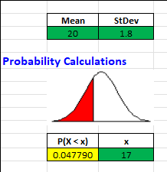
With the given values in the green cells, the probability of less than 17 is shown in the yellow cell as 0.04779, or a bit less than 5%.

In that same distribution, if we wanted the probability of more than 19, the middle distribution would be used. The mean and the standard deviation still be to be typed in at the top. It would look like this:

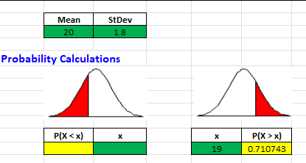
The probability of a value being more than 19 is 0.710743, or about 71%.

Finally, we can also determine the probability of a value being between two values of x. In this same distribution, we could find the probability of a value being greater than 17 and less than 19. In the spreadsheet, it would look like this:

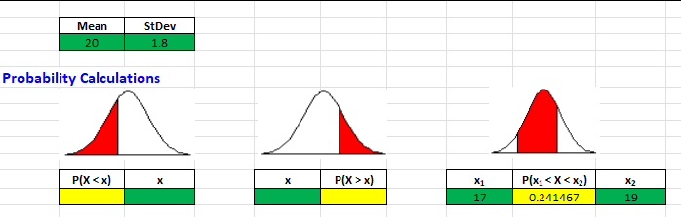

The P(17 < x < 19) is 0.24167 or about 24%. It is also true that P(17 ≤ x ≤ 19) = 0.241467. The equalities in a continuous distribution have a probability of nearly 0, so do not impact the probabilities.

Both the distributions below, A and B, are normal distributions. Since distribution A is shifted to the right, the values in that distributions are higher or larger than those in distribution B. Therefore, the mean of distribution A is higher than the mean of distribution B. The mean of a normal distribution is based on the position of the middle or high point of the distribution.

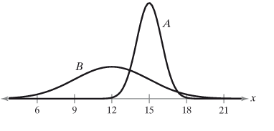
On the other hand, distribution B has the larger standard deviation as its values are more spread out or disperse than those in distribution A. The shape reflects the standard deviation.

Area and Probability
The total area under the normal distribution, of course reflects 100% of the area. The area is related to the probability. In the picture below, values of x less than -0.24 have a probability of 0.4052 occurring. The blue shared area shown below reflects 0.4052 or 40.52% of the total area under the curve.
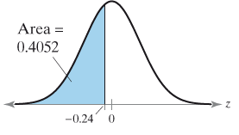
Unusual Events
The text uses the definition of less than 5% as being an unusual event. This is a common measure to use. Based on this definition, any event with a less than 5% chance of occurring would be considered an unusual event.

