Your Full Essay Title in Bold and Title Case

Your Full Name
Your College Department or Program, Your University
Course Number and Name
Professor Name and Title
Month day, year

Your Full Essay Title, Centered, Title Case, Bold
Writing essays in APA format is not as hard as it looks. This document provides instructions and a template for basic student essay content and format for title pages, headers, page and section titles, and paragraphs and citations. This template can be used for any assignment requiring APA 7th ed. formatting. It is strongly recommended that you do not use the Word or other APA templates you may find; each contains formatting code that may cause issues later. Please read this overview. AFTER reading, delete each piece of instructional content and replace it with your own. If you copy text into this template from another documents or source, be aware that the format of the original may come with the copied text and override the proper format given here. Paste in content from outside sources as “text only” to preserve this template’s formatting (See Figure 1).
Figure 1
Pasting content into Word as Text-Only
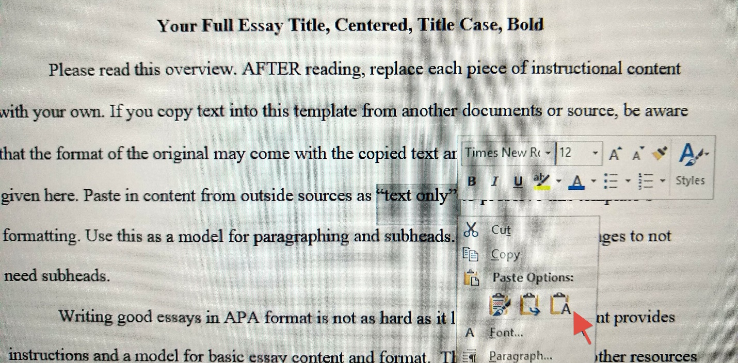
Note: Use CTRL-C to copy and CTRL-V to paste. Click on the icon that appears by the inserted content and select the rightmost option to remove outside formatting.
When you are done, your paper should be all the same font (ideally 12 point Times New Roman, or 11-point Calibri or Arial), double spaced, with 1” margins and no blank lines or spaces between paragraphs (in Paragraph menu, set “before” and “after” spacing to zero). Tab in the first line of each paragraph a half inch, allow Word to automatically wrap text at the end of lines, and Enter once at the end of each paragraph. You can find additional models on the DeVry Library and APA’s websites. Ultimately, you are responsible for meeting your professor’s expectations for assignments in that professor’s class, so follow all instructions and requirements expressed by the professor.
Essay Content and Organization
Essays with fewer than six pages should not have any sub-section titles like the one above. After the title page, only the essay’s first page of text and the References pages should include titles (bold and centered, same font style and size as the rest of the essay). For longer or more complex essays, mark sections with Title Case subheadings (bold and centered, same font).
Ask your professor for specific content and format expectations. Use the APA Style website, available print resources, and writing tutors for additional assistance. By carefully utilizing resources, you can produce a well-written and easy-to-read essay that meets APA requirements, avoids plagiarism, and shares your insights to make the world a better place.
When citing sources, you may use Word’s referencing function or copy in citations from RefWorks or other citation generators, be aware that they often import incorrect formatting and font size, color and styles. Be sure your essay formatting remains consistent.
Scroll down in this template to begin your references list on the page following your conclusion. If you are making your own document, do not enter multiple times to force a new page. Instead, on the line after your conclusion, CTRL-Enter or select Insert and Page Break from your top menu. Your cursor will be at the top of the next page, where you can center the title References and type your full APA citations. Please see the APA Style website and other APA guides for proper source citation in-text and on your references page.

References
FirstAuthorLastName, First Initial. Second Initial., Author’s Last Name, First Initial. Second Initial., & LastAuthorLastName, First Initial. Second Initial. (Year of publication). Title of the article. Title of the Magazine/Journal, Volume number(Issue number if known), page numbers. https://doi.org/10.####/#####.#####
AuthorLastName, First Initial. Second Initial. (Year of publication, Month date). Title of database article without a DOI. Title of Publication, page numbers. https://PermalinkProvidedInLibraryDatabase
AuthorLastName, First Initial. Second Initial. (Year, Month Day of publication). Title of article. Title of Publication or Online Source. https://full.hyperlinked/webpage.URL
List all sources you cited in your paper. Likewise, every source listed here must be cited in the actual essay. There must be a one-to-one exact match between your in-text citations/author tags and reference list entries.
Alphabetize your reference list by the first author’s last name or by the first main word of the organizational author. If there is no author, begin citations with the page or article title and alphabetize by the first main word.
Reference entries should use hanging paragraph formatting. That is, the first line should start at the left margin. Subsequent lines are indented .5 inches. To set a hanging indent, select the citations, then CTRL-T.
For proper APA citation content and format instructions, please refer to the APA Style website.

